Whit Schroder
ARCH 1150
Ömür Harmansah
27 November 2007
Suspended Purpose: How the Historic Crook Point Bridge has Escaped Providence’s Urban Renaissance
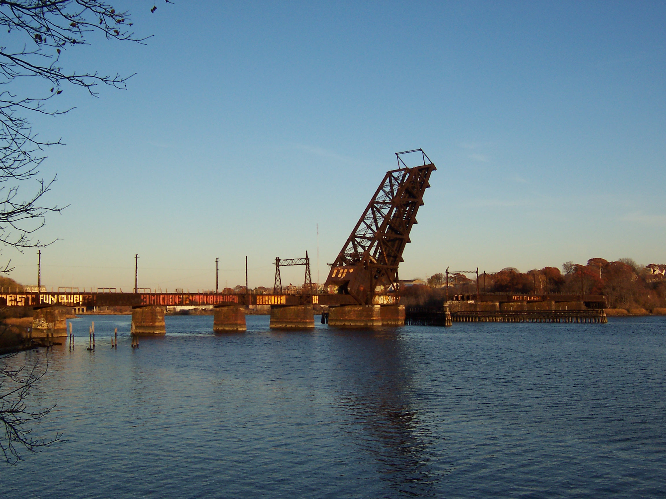
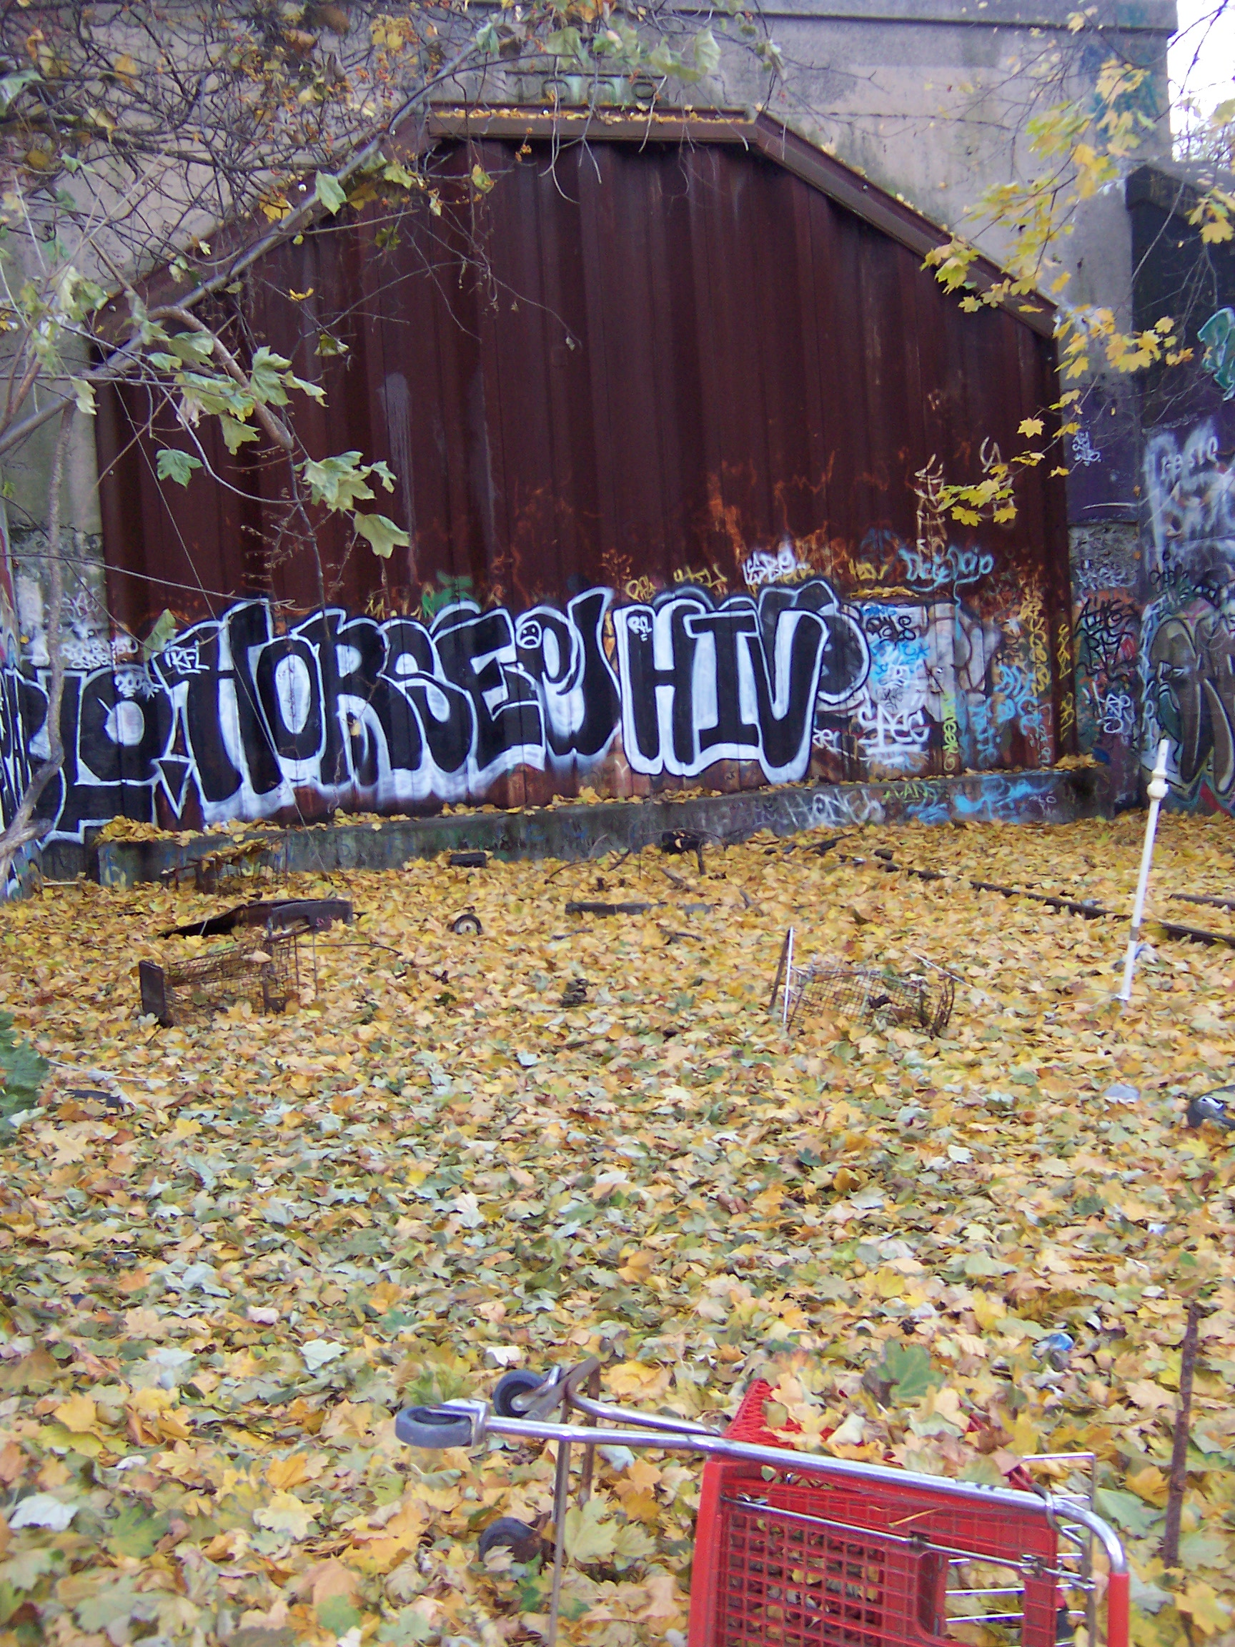
Driving east on Interstate 195 from Downtown Providence, the scenic landscape is something to behold. Cars cross the expansive estuary of the Seekonk and Providence Rivers that feeds into the Atlantic Ocean. But when one glances back to look at College Hill and Brown University, a much less natural sight steals the horizon. A rigid draw bridge stands frozen over the Seekonk River, pointing towards the sky. But no boat is sailing underneath. In fact, this draw bridge has been in this same position since 1982, hanging above the water. Literally suspended, the Crook Point Bridge has become a sight of decay: a suspended ruin, urban snapshot, or as Tim Edensor describes the “multiple temporalities of ruins” (Edensor 125). As the bustling city moves on, the Crook Point Bridge remains almost untouched, creating a “shadow realm of slowness in which things are revealed at a less frantic pace” (126). This idea of the Crook Point Bridge as a lingering landmark raises many questions, most interesting of which is why such a seemingly useless structure is still there at all.
Providence is a constantly changing city. Founded on revolutionary religious ideas and situated near the birth of the American Industrial Revolution in Pawtucket, Providence has always been in active transformation. Even today, the city’s recent so-called “renaissance” has been cleaning up much of Providence’s urban waste, in the form of abandoned mills and other dilapidated buildings, revitalizing, especially, the Downtown area. But even with these city-funded renewals, some sites are ignored and escape under the radar, remaining in their heterotopic state, as their surroundings are restored and put to use. The Crook Point Bridge, along with its connecting East Side Train Tunnel, is such a case in which the nearby urban landscape has been gentrified, leaving a snapshot of the past urban environment that is conspicuously out-of-place in the city’s rapid modernization. Examining this case study can provide insight as to how and why certain urban landscapes change while others do not, and how cities can address the issue of such urban wastelands.
Anyone who has lived in Providence for more than a month must already be well-aware of the Crook Point Bridge, and certainly everyone has a differing opinion of the structure. To some, the bridge is an ugly eyesore that serves no purpose or value, while others are intrigued by it. In fact, the bridge has taken on a symbolic property, adding to Providence’s character, as recognizable as the “Superman Building” situated Downtown or the tri-chimneyed power plant on the southern waterfront. But few are likely to take the time to research the history of this landmark, preferring to let it remain shrouded in mystery.
The Crook Point Bridge and East Side Train Tunnel were essentially a product of their time. Conceptualized at a time when railroad transportation was paramount, the bridge was constructed out of need for improved accessibility to Union Station in Downtown Providence from Bristol and cities farther south in Rhode Island. The tunnel had to be carved into College Hill in order to provide trains with a level track. From 1908 until the 1950s, the Crook Point Bridge and tunnel provided commuters from Bristol to Boston with an efficient means of transportation. But after the 1950s, train travel became less important, and this southern stretch of track in Rhode Island was used only by freight trains. Soon, even carrying freight by train had become too costly, and the track to Bristol was abandoned. Finally, the bridge and tunnel were entirely abandoned in 1982, never to be used again (more on that later).
Before the 1980s, Providence was a very different place from what it is today. Driving across the city during these years, a person would not have been surprised by the sight of an abandoned Crook Point Bridge. In fact, much of the city at this time was suffering from a surfeit of discarded space creating brownfield sites, and Providence became a stronghold of organized crime. The city’s so-called “renaissance” actually began in the late 1970s and flourished in the 1990s when the natural rivers that had previously been paved over were uncovered and major construction projects began, including that of the Providence Place Mall. Of pertinence to the Crook Point Bridge, the west entrance to the train tunnel near North Main Street was better incorporated into its surroundings, as the Providence-Worcester Bridge over Canal Street was demolished, and the old Union Station was replaced with the new Amtrak Station.
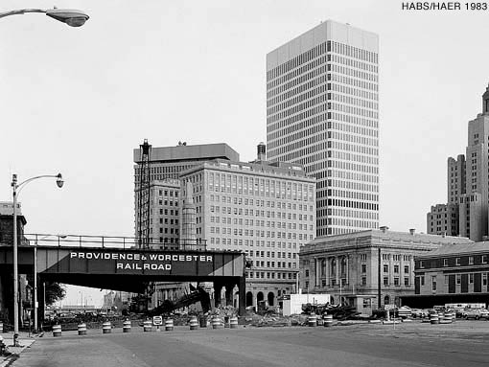
The Providence-Worcester Bridge connecting the train tunnel to Union Station

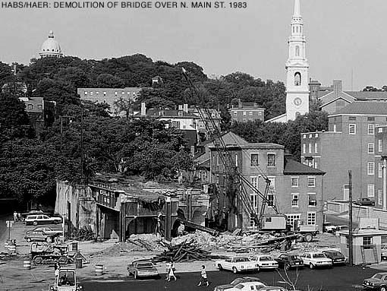
The demolition of the Providence-Worcester Bridge
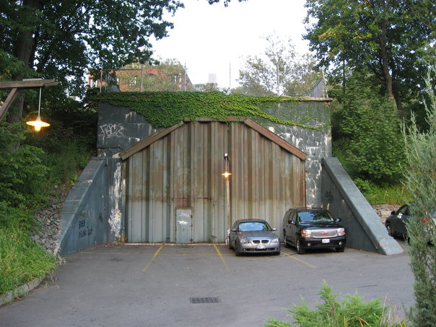
The western entrance to the East Side Train Tunnel
If an answer to the initial question introduced in this paper was difficult enough to comprehend, the fact that the city of Providence funded the demolition of a similar bridge to the west while leaving the Crook Point Bridge in its place seems preposterous. An obvious explanation for this incongruity might be that the city began its revitalization project at its center, considering the renewal of sites to the east less important at the time.
However, an examination of other construction projects sometimes literally alongside the Crook Point Bridge proves that such an easy explanation is not logical. In 1983, while the Providence-Worcester bridge was being demolished in Downtown Providence, Governor Edward DiPrete approved a plan for Rhode Island’s first major bike path from Providence to Bristol. Does that ring a bell? The newly obsolete railroad that crossed the Seekonk River had formerly connected Providence to Bristol. Not surprising, the East Bay Bike Path, completed in 1992, follows precisely the path of the old tracks. Even today, bikers can see the overgrown rails alongside the entire stretch to Bristol. Thus, shortly after the closing of the East Side Train Tunnel and the raising of the Crook Point Bridge, their limits to both the east and west had already been rejuvenated.
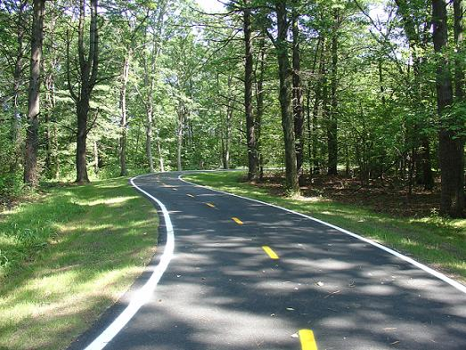
The East Bay Bike Path, the abandoned train tracks are barely visible to the right
Perhaps another explanation is that the city’s budget was large enough for these two projects, but not for any other construction. However, again driving on Interstate 195, the abundance of construction signs serves as a reminder that a major project is currently taking place within the vicinity of the Crook Point Bridge. Slated for completion in 2009, the interstate is being relocated and rerouted in order to limit its number of sharp curves, making the stretch safer for traffic and freeing space. The demolition of a number of abandoned buildings was necessary for this project to take place.
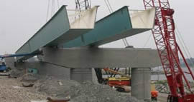
New I-195 ramp under construction in Downtown Providence
Clearly the city has little interest in funding such a revitalization of the Crook Point area. However, if the city is concerned for safety, as is evident with the rerouting of Interstate 195, the Crook Point Bridge and tunnel are major liabilities, especially after numerous suicide attempts from the bridge as well as the “riot” that took place in the tunnel in 1993. The reason such a conspicuous structure can slip under the radar by avoiding demolition or gentrification must be its location. The abandoned railyards that were situated Downtown where Waterplace Park is today were of interest to the city of Providence because they negatively affected the aesthetics of the city’s commercial center. The abandoned tracks between East Providence and Bristol interested the state of Rhode Island because they were unused space, not suitable for roads or highways but perfect for a bike path that could connect Providence to Bristol and the numerous state parks in between. The relocating of Interstate 195 improves accessibility to Downtown Providence and the Jewelry District, and so affects Providence. The Crook Point Bridge, however, is of little concern to anyone. Hanging over the Seekonk River, the dividing line between two different cities demolishing the bridge or revitalizing the area would impact neither Providence nor East Providence. For this reason, the Crook Point Bridge still stands after more than twenty years of disuse. The East Side Train Tunnel, on the other hand, lies directly beneath Brown University. The only way gentrification of the Crook Point Bridge can take place is through a joint venture between the university and the city of East Providence.
In fact, such a plan has recently been conceived. Announced in the summer of 2003 by a Brown graduate, Richard Manchester, the proposal includes a number of housing units, parking, and open green space, as well as a plan to connect this area to Downtown Providence through a tram system running across the Seekonk River -- over the Crook Point Bridge -- and under College Hill – through the East Side Train Tunnel (Asarnow http://www.brown.edu/Students/INDY/alpha/article.php?id=11&issue_id=185). Brown University has obviously taken interest in this project, as the Corporation is currently pursuing options for constructing new housing and parking for undergraduates. With Manchester’s plan, students could park their cars in East Providence and “hop a rubber-wheeled ‘train’ that would whisk them to a proposed underground stop at Thayer Street, or to the edge of Providence’s downtown, in a manner of minutes” (http://www.artinruins.com/arch/?id=decay&pr=eastsidetrain). Above all, however, East Providence’s waterfront, the longest in all of Rhode Island, would be revitalized and “could be an urban park on [the scale of Central Park]” (Manchester). These types of proposals often take time to be implemented, and Brown University is hesitant to get involved, but in the future, the Crook Point Bridge may be given the interest it deserves.
But what should be done with the Crook Point Bridge? Whether the East Providence Waterfront Special Development District Plan (http://www.eastprovidencewaterfront.com) is implemented or not, the Crook Point Bridge should not be demolished. Again, the bridge has become a symbol of Providence and a site of memories. As Edensor describes, “the temporalities of ruined factories […] conjure up various histories, evoke a range of memories, signify obsolescent fashions and products, bear the imprint of the timed schedules of yesteryear, and testify to the natural temporalities imposed by decay,” yet they also “contain a still and seemingly quiescent present” (Edensor 125). Anyone who has visited the bridge has a special story to tell. East Providence’s waterfront plan could be implemented and the Crook Point Bridge could be incorporated into the new environmentally safe space. Similar revitalization projects in Providence have cleaned up environmentally hazardous sites while preserving historic buildings. As part of the Greenway Project, Providence is creating a park on a former brownfield site as well as a bike path that connects the Olneyville neighborhood to Johnston. This area was initially covered by acres of large woolen mills, known as Riverside Mills. After they became abandoned, much of the site was destroyed by major fires in 1989 and 2001. Today, the only historic building that was saved is being incorporated into the park and could essentially serve as a visitor center (http://www.artinruins.com/arch/redevelop/amerwool). Such a plan in East Providence, in which the natural environment is enhanced and the historic buildings are preserved would be ideal.
Thus, the Crook Point Bridge is at an important place in its history. At one time an invaluable space of constant movement and activity, the bridge is now a forgotten artifact of a once important form of transportation. Will it be incorporated into an exciting new project that could revitalize one of Rhode Island’s most scenic waterfronts? Will it eventually be demolished in order to combat the less legal activities that take place at the site? Or will the bridge stay in its current position, producing a slowly accumulating waste (Edensor 126)? The bridge has managed to survive decades of gentrification and demolition of abandoned spaces. Only time will tell of the future of the Crook Point Bridge. The bridge will just have to keep waiting, suspended in time as the surrounding world changes.

Works Cited
Asarnow, Jenny. “Burrowing Development.” The College Hill Independent. 2003. http://www.brown.edu/Students/INDY/alpha/article.php?id=11&issue_id=185
Boyle, Jeanne M. “Welcome to East Providence, Rhode Island.” East Providence Waterfront Commission. Updated 2007. Accessed 27 Nov 2007. http://www.eastprovidencewaterfront.com
Edensor, Tim. Industrial Ruins: Spaces, Aesthetics, and Materiality. Oxford, New York: Berg, 2005.
No author given. “East Side Train Tunnel.” Art in Ruins. Updated 2007. Accessed 27 Nov 2007. http://www.artinruins.com/arch/?id=decay&pr=eastsidetrain
No author given. “American Woolen Company.” Art in Ruins. Updated 2007. Accessed 27 Nov 2007. http://www.artinruins.com/arch/redevelop/amerwool

