Carissa L. Racca
Professor Harmansah
AE-1150
27 November 2007

Urbanism in Perspective: Tunnel Life
AN EXPLORATION OF THE EAST SIDE RAILROAD TUNNEL, PROVIDENCE, RHODE ISLAND

Introduction: Railway Identity

My first discovery of the old abandoned East Side Railroad Tunnel did not come as a spontaneous act of urban exploration. On the contrary, my acquaintance with the urban ruin was predetermined, a stop on a walking tour, which allowed my fellow classmates and myself to further explore the city landscape by foot. While, being guided up the long, narrow stretch of driveway at the unnumbered 101 North Main Street, my attention became unfocused, captivated by a massive beige structure that was both hidden away and exposed to the urban environment. When I began to look at research for this project, my appreciation for the abandoned tunnel structure grew. In many ways, I was constantly reminded of my child-like inhibitions that prevented me from further exploring such derelict structures.
The East Side Railroad Tunnel, like many of the other “ruined places,” similar to those mentioned in Tim Edensor’s book “Industrial Ruins: Spaces, Aesthetics and Materiality,” reminded me of this notion that ruins are spaces of waste; this paper is evidence that this is not necessarily true. Granted, the tunnel’s existence has been carried out in the shadows of far more glamorous edifices of downtown Providence that exude a utopian quality, but there is no justification to allow it to be forgotten. Here, I will not only look at the East Side Railroad Tunnel as apart of the Crook Point Bridge structure, but as a product of industrial ruination of the now defunct railway systems of early 19th century America. This place, like many, has its own story to tell. For this project, I not only wanted to incorporate historical accounts of the place, but to include more personalized experiences, ranging from different visuals to personal stories that recount an intensified nostalgia of past tunnel experiences. My ultimate goal is to illustrate that ruins are symbols of collective memory and that they should not be forgotten.

History of the Site

The East Side Railroad Tunnel was conceptualized by the Providence Railroad company in 1903. The tunnel, like many other local railways, was considered to be part of the “rail road boom” of the early 19th century. Before, the commercialization of the automobile, railroad service was locally extended to the East Side in 1908, with the completion of the East Side Railroad Tunnel. The tunnel and viaduct at the time connected all rail traffic from various locations that included the Fall River, Massachusetts area, and the eastern shore of Narragansett Bay with the main shoreline route of New York, New Haven and Hartford Railroad. The long, arduous tunnel construction plan was one that lasted thirty years. Ultimately, the city’s vision was that all rail traffic be brought directly into the city’s Union Station (located in downtown Providence) without having to make a time-consuming transfer at Fox Point. Essentially, the tunnel once united the Seekonk and Providence River systems. The Crook Point Street Bridge, the erect structure often referred to as the “Scherzer Rolling Life Bridge,” which is a continuation of the railroad track from the East Side, remains an everlasting reminder of the once flourishing railway systems of the Providence area.
The east tunnel, which can still be seen today, is situated between North Main and Benefit Streets. Passenger service for this route ceased in 1937, since then, the tunnel has only been used for light fright traffic until the 1980’s. All access to the tunnel had been blocked off in the present day; however, I believe that you can still gain access from the western end. The bridge, which remained in addition to the tunnel, was demolished in 1982, when the new Amtrak station in downtown Providence was built. It was the first phase in the realignment of the tracks for the Northeast Corridor Project.

Tunnel Talk

To gain a more personal perspective of the usage of the tunnel, I relied on various peoples accounts of revisited tunnel memories and experiences. Below, I will try to incorporate some type of visual evidence with each person’s account. It is apparent that the East Side Tunnel not only functioned as a space that has taken on its own identity, in which it resembles a dark playground for adults (Edensor, p.27). Before the closure of the tunnel, the place resembled other structures of urban decay where people could indulge in drinking or drugs without the constant monitoring of the urban environment.

I have only edited these responses to make them grammatically correct. They are in the same format as displayed on the website.
Tim G (Pawtucket): I and a few friends went into this tunnel about 3 years ago. We were very interested in the old bridge and followed the tracks only to discover it. We went inside with a flashlight. There was a lot of old junk in there. It is mostly flooded but there are wooden crates to walk across. There is a flipped over junk car at the mouth of the tunnel. I tried to identify it but I can’t tell what it is. I went to the tunnel recently but the door had been welded shut.
JR: When I was in high school in Providence (School One, when it was still on John Street) in the late 80s early 90s, we used to drink beer and do other bad stuff at the mouth of the tunnel off Gano Street. I don’t think I ever went very far into the thing, but plenty of people I knew had, and for some it was a right of passage to finish off a 40oz of Haffenreffer (or two) and make your drunken way to the other end. Those were definitely the days.
Katie: My dad was telling me about this one time he went to the tunnel with a bunch of his friends, and their bikes, sometime in the 80s. Apparently, it was early morning, and there was fog shooting out of the tunnel, because the air from the other end, forced it out the end he was going to enter near. When the fog stopped, and they went in, there was lots of water near the ground, and some dripping off the ceiling. He said that at some points it was so deep they had to walk their bikes through. Also, he said that there we open manholes, so you had to be extremely careful, so as not to fall through one. He said it was an extremely creepy experience, but a really awesome one too, because it had a sense of danger and trouble.
From Providence Today (Jan 12, 06), the Mayor announced that he favored some sort of streetcar/light rail system for Providence. My personal thoughts, “Where the hell are you going to put it? Every other city that’s done a light rail system either is low density or has a disused railroad track… oh wait…” A $2 million tunnel in good structural shape sitting around that would cost hundreds of times this today? That qualifies. Hope the Transit 2020 Working Group sees this.
Bob E: I remember “the tunnel” when I worked near it in the early 80’s. It was a bane for the police dept in many ways. Homeless drunks, drug addicts and sometimes demented people (as someone documented an encounter with) lived in there and would clamber up the side to Benefit Street to beg, or accost people on North Main. One news making event involved RISD students having some kind of year-end party ritual that was like the aforementioned LaSalle one, only that it was far more “artsy” and tribal in nature-kind of like a proto Rave party – it involved drums, torches, bonfires, running naked (in some cases) and chanting and overall boisterousness. Police were called in for what was called in about as a “Satanic ritual” (hardly) and a near riot occurred when they shut it down, lots of people hauled in including bystanders on Benefit, one of whom was apparently injured, mistaken for a reveler. That was about the time, they decided to board it up as I recall. It had an urban legend of creepiness about the whole place that fit well into H.P Lovecraft mythos in Providence and I even knew a guy who wrote a horror story about it.
Bob D: When I was a teenager back in the 70’s, I and some friends often “humped” long freight trains and would ride them for several miles. We would either hang on the ladders or sometimes hop into an open car. On at least one occasion we rode from E. Providence, across the Jack Knife Bridge and through the entire tunnel into downtown Providence! We walked through the tunnel many times and it was always an adventure. We would always encounter some low-lifers who would threaten us, and it got pretty loud in there when a train would go by. You could create some great echoes in there also. Looking back at those years, this was definitely some of the more dangerous and stupid stuff we did.
M-Foran: My friends and I walked through the tunnel back in ‘89. Despite that it was the middle of the day, the tunnel quickly submerged us in total darkness, and we had brought no lights with us. As we carefully navigated the track, all that was visible was the bright pinpoint of light from the opposite end. It was an amazingly cathartic experience and when we emerged from the tunnel on the east side we all felt like we had somehow been reborn.
We took several trips through the tunnel in the year that followed. Once we brought torches, but, while fun, it definitely lessened the experience. Plunging oneself into total darkness in an uncertain landscape frightened us, and made our other senses more alive.
On one of the trips, we were confronted by a huge guy and his disfigured little friend, who were in the process of finishing off a case of Bud cans by the bridge on the east side. We didn’t even notice them off to the side of the tracks until the big one said “Hey! Did you make a noise!” and the little guy goes “We gonna f--- you UP!” After 20 extremely uncomfortable minutes I guess they decided we weren’t worth the effort. So we walked back home above ground, laughing off our strange fortune.
some guy that hates Providence the tunnel is neat; supposedly the Brown SciLi’s foundations are visible underneath?
Hatari: I been in the East side tunnel numerous times it is definitely a place to visit I remember the first time we came across a hobo and tried to kick us out of his so called home but gave him a dollar and he shut up, there is a lot of history about that tunnel it’s just a fun place to explore especially for beginner to advanced explorers.
Troth Specks: Before the fancy restaurant was there, the downtown side of the tunnel was enclosed by trees and shrubs. great place to go in the summer, as when the tunnel door was opened tons of cool air spilled out. I did walk in on some shady dudes in suits conducting business down there once.
A Wood: I remember my first experience in the Gano Street tunnel. Seniors from La Salle decided to have a “tunnel party”. They put all the wooden planks down to provide access through the flooding opening of the tunnel. The main sources of light were torches that provided a certain “Temple of Doom” atmosphere. The had a radio playing a drum. It was a fun night. I think everyone should see this tunnel once in their life. Oh and welding the door shut never works, we always find a way in.
The Tunnel Party Incident of 1990
While, many urban spaces are often regarded as unguarded, tunnels are sites of refuge not only reserved for alcoholics and drug addicts, but are often considered havens for disorganized parties such as raves. These types of activities are often regarded as chaotic forms of recreation that lead to destructive acts of vandalism. They are often seen as outlets of escapement from an organized society.
One particular incident that occurred in the East Side Tunnel, which has now become something of a legend, took place on May 1st. 1993. The only reliable information source other than the actually article itself was found on the website: http:// www.antirins.com. It has been said that a group of students gathered at the western portal below Benefit St. for a Beltain-May Day party (Beltain is the original Celtic Halloween celebration). It is said that the group lit fires, put on animal masks, and pounded on drums until the early the next morning when college security officers attempted to break up the so-called revelry. “There was an argument about jurisdiction-the students telling the security officers that they had none at the tunnel. One participant who was playing a drum as was told to leave, however, he wouldn’t stop. One of the officers tried to take his drum sticks and a fight started between them. The officers retreated and called for Providence Police to help.”
By the time the police arrived, the party had gained more attendants and they refused to disperse. The situation escalated quickly. The police tried to gain control of the situation with tear gad and the students answered with rocks and bricks. “The cops formed a riot line with locked arms and walked through the kids. A friend of mine breached the cop line. They beat him down and arrested him.” The police in charge in the next day’s paper had indicated that they encountered “satanic rituals.” As a result the tunnel was closed with thick corrugated steel, pierced at each end only by a locked door.
For the past few years the tunnel had been forgotten, and the entrance under Benefit Street was known only to local graffiti artists. When construction began in 2000 to renovate 101 North Main Street and construct a new building at 2 Thomas Street, the steel doors covering the tunnel entrance were painted and the lot was cleaned up and made into a surface parking lot.
Conclusion
The East Side Tunnel, like many other industrial ruins that litter the urban landscape, remains in many ways forgotten, until they are discovered. The tunnel itself has assumed an identity far beyond its physical scars of renovation projects, local graffiti artists and people who explore it. It has almost assumed a local cult following with people who have experienced it. Today, the site itself just sits unnoticed by pedestrians and homeowners who fail to realize what they live on. I am still planning my own exploration.

Images
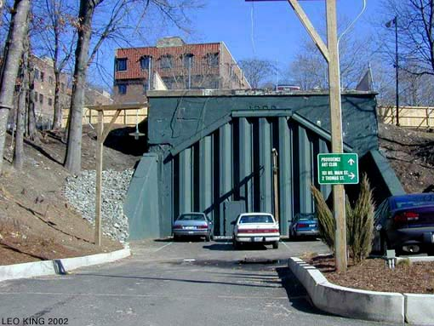
Image 1. View from the East Portal of the East Side Tunnel, facing North Main Street. 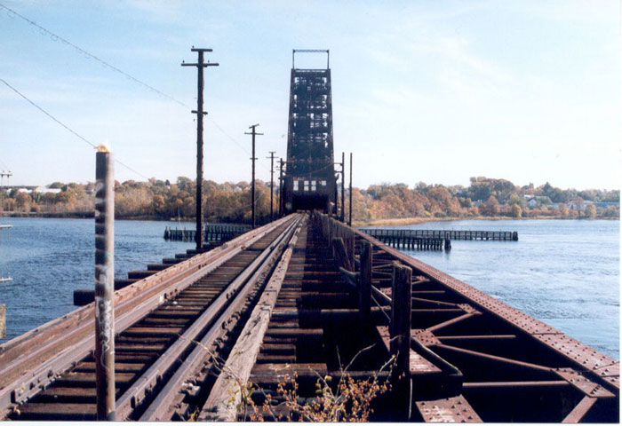
Image 2: The “Scherzer Rolling Lift Bridge” at Crook Point, built circa 1908 and abandoned in 1976. Also formally known as, the Seekonk River Drawbridge S.S. K-315, which carried Providence, Warren & Bristol train line. Image Source

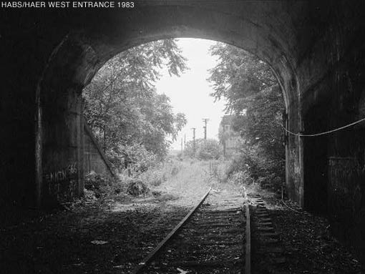
Image 3: West entrance of the train tunnel (1983)

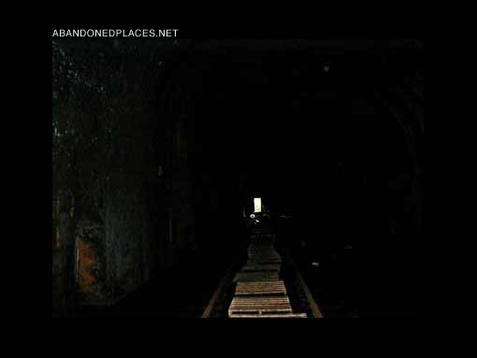
Image 4: Entrance to the tunnel from the east looking towards the west entrance.

Works Cited
Edensor, Tim. Industrial Ruins: Spaces, Aesthetics and Materiality. New York: Berg, 2005.
“East Side Railroad Tunnel,” 2007, Art in Ruins website, 25 November 2007,
< http://www.artinruins.com/arch/?id=decay&pr=eastsidetrain>

