Whit Schroder
ARCH 1150
Ömür Harmansah
20 December 2007
Urbanism at Amarna: The City of Akhenaten
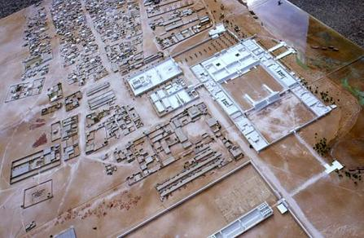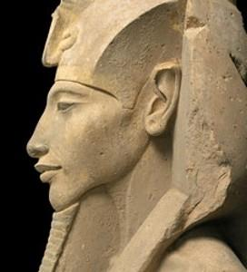
During the middle of the 18th Dynasty, Ancient Egyptian civilization was at an economic and artistic peak. Beginning with the expulsion of the Hyksos, or foreign rulers, who had taken over Egypt during the Second Intermediate Period (a dark age between the Middle and New Kingdoms) the 18th Dynasty gave rise to some of Egypt’s most powerful pharaohs, whose fames endure to this day. The early rulers of the 18th Dynasty reassumed their dominance over the region, leading numerous campaigns against the Hittites and Assyrians to the North and the Nubians to the South. Finally, the rule of Amenhotep III was characterized by peace and wealth, something unprecedented in Egyptian history, attesting to the renewed interest in foreign relations and tribute gained from the various conquered enemies.
But Egypt’s stability would not last long. In the middle of the 14th Century BC, Amenhotep III’s son and successor, Amenhotep IV, adopted the main worship of a single god, the sun-disk Aten, eradicating the Egyptian tradition of polytheistic worship that had lasted for millennia and drastically altering art and architectural styles to reflect this new freedom of expression. Amenhotep IV, whose title meant “Amen [a major god in the Egyptian pantheon] is satisfied,” even changed his name to Akhenaten (effective spirit of Aten) in order to better suit the adoration of Aten. Furthermore, the heretic pharaoh moved the Egyptian capital from Thebes to a new city farther north, which he named Akhetaten, more commonly called Amarna, after a nearby, modern village. A study of this new disembedded capital’s urbanism, architecture, and the private life of its citizens allows archaeologists to compare textual evidence from the period with material remains discovered at the site, in an attempt to understand more this bizarre digression from typical Egyptian history, and how it affected daily life in Egypt.

TEXTUAL INTERPRETATION VS. ARCHAEOLOGICAL EVIDENCE
A major difficulty that arises in the study of Egyptology, and especially in the study of the Amarna Period is the discrepancy between textual evidence and archaeological remains. Ian Shaw underscores the fact that “throughout the pharaonic period the particular kinds of evidence provided by archaeology and texts are often difficult to reconcile satisfactorily” (Shaw 1996: 89). This difficulty becomes apparent in the study of the founding of Amarna. According to stories discovered on the Amarna Boundary stelae, placed by Akhenaten to mark the periphery of the city, the pharaoh was searching for a place to build the new capital, when he saw the sun setting in the gap between two mountains. Akhenaten, convinced that the Aten had given him a sign, decided to build the city in that new spot, naming it Akhetaten, meaning “horizon of the Aten” (the Egyptian hieroglyph for horizon shows the sun setting between two mountaintops). Akhenaten clearly stated that he had not chosen the place to build the new city, nor was he given any advice on the matter, other than that from the Aten:
“The Orb is desirous that there be ma[de] for Him […] as a monument with an etern[al] and everlasting name! Now, it is the Orb, my father who advised me concerning it, (namely) ‘the Horizon of the Orb.’ No official had ever advised me concerning it, (and) not any of the people who are in the entire land had ever advised me concerning it […] Behold, I did not find it as reclaimed land […] not as a ‘residence,’ nor as an administrative entity.” (Murnane and Van Siclen 1993: 37)

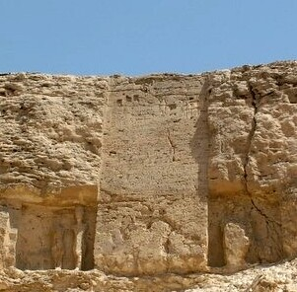
However, Akhenaten may have had other reasons to choose this site as the new capital. Akhenaten, wishing to disassociate himself from the Theban priesthood, placed Amarna almost equidistant between Thebes (the capital during the New Kingdom) and Memphis (the capital during the Old Kingdom), possibly in an attempt to appease both the south and north regions of the Nile. Any other time in Egyptian history a dynasty had attempted to found a new capital, the civilization had become fragmented into two or more rival regions. Akhenaten may have been well aware of the events of the Second Intermediate Period that had occurred a few centuries before. During the Second Intermediate Period, three contemporaneous dynasties ruled from Avaris, Thebes, and Abydos, respectively. Previously, when Egypt had descended into a dark age, one dynasty ruled from a capital far to the north, while another dynasty ruled far to the south. Akhenaten, avoiding such a situation, placed his capital right in the middle of the country.

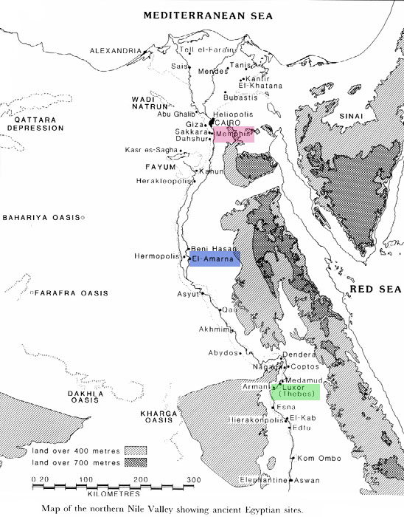

AMARNA AS A DISEMBEDDED CAPITAL
Alexander H. Joffe, in his chapter entitled “Disembedded Capitals,” suggests another reason for the position of the new capital. Generally, when a capital was moved, or disembedded, that city had to remain self-sustaining to succeed, albeit temporarily. According to Joffe, “though they were part of developed state systems with complex economic interlinkages, the disembedded capitals […] all appear to have had adequate local resources and rural hinterlands to be agriculturally self-sufficient” (Joffe 1998: 569). In the case of Amarna, the city would have had to be able to sustain itself because of its isolation from Egypt’s major cities. Ian Shaw has observed, based on information from the Amarna Boundary stelae and other textual information, that “the settlement was founded by Akhenaten in the fourth or fifth year of his reign, and was clearly intended to be a new capital city, dedicated to the Aten and therefore purposely established on a virgin site so that the new temples could be built on ground untarnished by any previous religious structures” (Shaw 1996: 92). However, Joffe suggests that Akhenaten may have begun construction at Amarna while he served as co-regent to his father Amenhotep III, and, in fact, that the site probably already had agricultural villages and craftsmen before the capital was moved there. The city “was thus partially complete when Amenophis [a different transliteration of Amenhotep] IV assumed the throne” (Joffe 1998: 553). Whether a small settlement existed at Amarna prior to Akhenaten’s reign is an interesting suggestion that can only be answered by further archaeological work. Fairly obvious, however, is the fact that the story attested in texts such as that on the boundary stela was romanticized, possibly to reinforce the idea of divine intervention and connection to the pharaoh on Earth. Pharaohs and “imperial leaders customarily seek to seize control of sources of legitimacy, through the cooption of local religious beliefs and/or the creation of new systems of belief that build on traditional elements” (Sinopoli 1994: 167-168). Akhenaten had full support from a deity to move the capital to Amarna.
These types of justifications were common in Egyptian history. For example, the Dream Stela, dating to the early 14th Century BC, in front of the Sphinx tells the story of how Thutmose IV, Akhenaten’s grandfather, became pharaoh. Apparently, the young prince was resting by the Sphinx, when the creature came and spoke to him in a dream. The Sphinx told Thutmose that if he cleared away the sand and restored the structure, he would become pharaoh. The Dream Stela was, essentially, a form of propaganda to explain Thutmose’s usurpation of the throne. Thus, pharaohs often justified their actions through myths written on stelae.
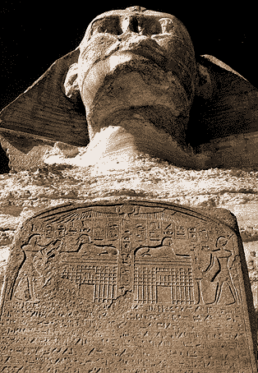

SUDDEN CHANGES
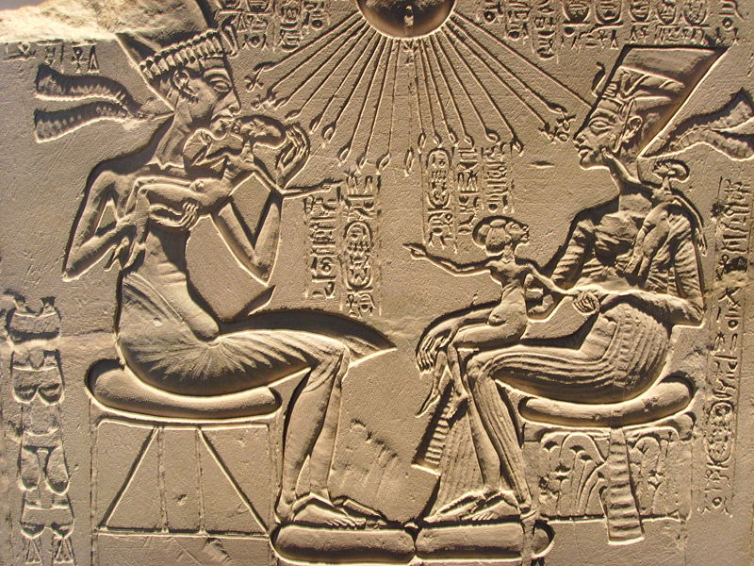
Akhenaten, in fact, took advantage of this idea, through art discovered at Amarna. Wishing to be ubiquitous and always visible, Akhenaten covered temples and palaces with reliefs depicting the pharaoh. This propagandistic art was common in Egypt, as seen during the reigns of Thutmose III and Ramses the Great. The art showed military battles, the conquering of weaker civilizations, and the taking of thousands of prisoners, even if Egypt had, in fact, been defeated. But Akhenaten’s art was far removed from such depictions. He showed no battle scenes; no images of the pharaoh smiting enemies. Not merely did Amarna art reveal a complete stylistic change but also a thematic reversal. Reliefs at Amarna blatantly showed the pharaoh with his wife and daughters. Often, the pharaoh even kissed his daughters – such an intimate scene was unheard of in Egypt. The paintings and wall carvings all differed slightly, but one thing was always present: the sun-disk Aten. Wherever Akhenaten was portrayed, the Aten was always with him. Akhenaten had to prove his adoration of the single god by displaying scenes of himself and his family worshiping the deity. Again, these scenes could have also been used as propaganda to reinforce the acceptance of the new religion.
Indeed, the original name of the city itself strengthened the king’s propaganda. The similarity between the city’s name, Akhetaten, and the pharaoh’s name, Akhenaten, cannot be mere coincidence. Akhenaten may have been merely an arrogant king attempting to assert his power by naming a city after himself and spreading propaganda. Yet, the two words Akhetaten and Akhenaten are similar to each other because they both share a common ending: Aten. Akhenaten’s name was actually far from echoing self-importance but, rather, dedicated to the god Aten. The pharaoh, ever faithful to his god, not only named himself after the Aten but also dedicated and named an entire city for the sun-disk. Akhenaten, then, was not asserting his own power but affirming the legitimacy of a single god, in an attempt to balance the powerful cult of Amen-Re at Thebes. Akhenaten, Akhetaten, and the Aten itself were meant to be difficult to distinguish among each other, remaining inseparable.
Founding a new city and introducing a new art style were not enough to unite Akhenaten with the Aten. Akhenaten and the Aten were not only always visible together in art, but the royal family also had to be seen on a daily basis. This notion is reflected in the unique architecture of Amarna. Because Amarna was occupied so briefly, between twenty and thirty years, and abandoned so rapidly, it remains one of “the only virtually complete ancient towns to have survived from ancient Egypt” (Shaw 1996: 92), a virtual snapshot of history. However, architecture at Amarna is not representative of the style used throughout Egyptian history. The typical Egyptian temple was meant to be private and heterotopic, in which columned halls stretched deep into a dark, inner sanctum, as the floors gradually rose and the ceilings became lower. In contrast, at Amarna, in the center of the city, the Great Temple of the Aten, one of the earliest buildings at Amarna, consists of “a succession of unroofed courts filled with altars […] The painted reliefs in some of the rock-tombs at el-Amarna show the royal family processing through the open spaces of the Great Temple to make offerings to the Aten on sun-drenched, open-air altars, in stark contrast to the more claustrophobic depictions of the celebration of the cult of Amun-Re at Thebes” (Shaw 1996: 96). This architecture supports Akhenaten’s will to make his worship of the Aten as conspicuous as possible. The Smaller Aten Temple’s plan matches that of the Great Temple, as do many other royal edifices in the center of Amarna. Akhenaten was hiding nothing at Amarna – the city was designed to encourage the open worship of the Aten.
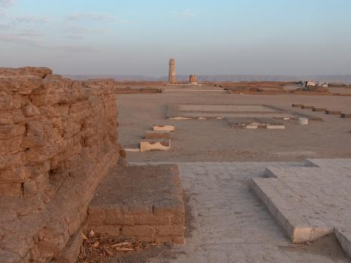
The visible nature of architecture at Amarna, in a way, contributed to the citizens’ worship of the Aten through the royal family. Akhenaten was the true and only connection to the Aten, so he was obliged to make frequent appearances before the elites of the city. As Shaw observes “the presence of ramps and steps flanked by balustrades in most of the major buildings at el-Amarna suggests that Akhenaten was obliged to devise innovative architectural forms to provide suitable contexts for the worship of Aten” (Shaw 1994: 109) as Diane Favro and Fikret Yegul wrote of the utilitarian street designs in Rome and Ephesus, respectively (Favro and Yegul 1994: 151-164). In fact, Amarna was similarly dominated by a main street, the “Sikket es-Sultan,” running straight from north to south, as at the Mesoamerican site Teotihuacan (Webmoor 2005: 52-84). The main street linked the North Riverside Palace at the northern end of the city to the bustling city center. Reliefs in tombs and temples show scenes of the royal family riding chariots down the “Sikket es-Sultan,” appearing before their citizens. This appearance was crucial to the support of the pharaoh and the new religion.

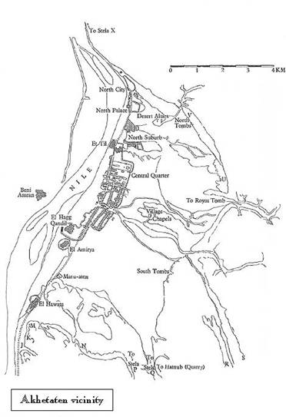
Over the main street, at the very center of the city, lay a massive bridge over which the royal family passed when traveling from the Great Palace to the west and the King’s House to the east. This bridge even incorporated a “window of appearances” where “the king and queen would appear […] in order to receive the obeisance of their subjects and to present rewards to the elite members of the court” (Shaw 1996: 97). Reliefs and paintings depict the royal family happily handing gold bracelets and jewelry to loyal supporters, under the welcoming light rays of the Aten. But Akhenaten’s gifts may have actually served as bribes to insure that the elites continued to support him and his new religion. Indeed, the elites “must have felt the full brunt of the reforms, as they would have been obliged to change their names, their religious observances and even their homes (in the case of those officials who moved to el-Amarna)” (Shaw 1996: 89-90). At the center of the city, the window of appearances would have insured that the king remained visible throughout the day, when traveling between palaces and temples, reminding the people of his power. The ramps, balustrades, and window of appearances would have all been impressive architectural designs to assert the king’s strength and the existence of the Aten.
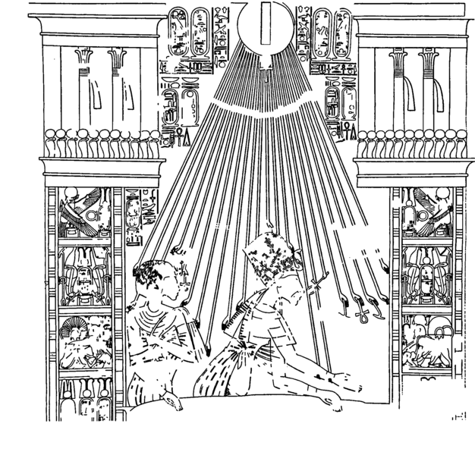

ELITE LIFE AT AMARNA
The support of the pharaoh, though normally accepted without a second’s thought, must have been extremely difficult, however, under the rule of such a heretic king. But, scribes loyally followed the will of the pharaoh by etching out names of old gods and depicting scenes using a questionable architectural style. A number of elites and commoners even followed Akhenaten to a new city, miles away from any of Egypt’s major cities. How did these people almost automatically accept these bizarre, new ideas? Was Akhenaten a tyrant who forced his beliefs on his people, or did they willingly convert? To answer these questions, archaeologists have turned to the houses and tombs of nobles at Amarna. Tomb 11, belonging to Ramose, possibly the vizier of Akhenaten’s father, Amenhotep III, shows the ambivalence, between supporting the pharaoh and honoring Egyptian tradition, that Akhenaten’s subjects may have felt. The construction of a tomb typically began before its owner died. Tomb 55 at Thebes was actually intended to be Ramose’s tomb, but when Akhenaten moved the capital to Amarna, a new tomb (11) was constructed for the vizier. Part of this tomb was designed in the traditional Egyptian style under Amenhotep III and previous pharaohs, while the other half juxtaposes these paintings with scenes in the Amarna style of Akhenaten and his queen Nefertiti rewarding Ramose at the window of appearances. Ramose, a loyal subject of Amenhotep III and his son, probably died an extremely confused man, wondering what would happen to him in the afterlife. The vizier likely moved to Amarna of his own accord or benefit, believing the pharaoh was omniscient. The nobles were obliged to, and thus likely willingly, follow the pharaoh, no matter how odd his actions.
But if these elites felt so strongly about supporting the pharaoh, would they have helped with the construction of the city in order to show their loyalty to Akhenaten and the Aten? In other words, what activities, other than physically moving to the new capital, did they perform in order to cause Akhenaten to reward them at the window of appearances? Some evidence from Amarna may suggest the nobles practiced a form of eugertism, a Greek gift-giving ceremony through construction projects performed by elites to improve city space. Akhenaten’s gift-giving at the window of appearances, indeed, was a sort of eugertism, whereby he legitimated his government of the city (Isin and Lefebvre 2005: 5). A look at some of the residential areas and suburbs of Amarna reveal that nobles may have supported each other by sharing space and skills. The “private residential areas are characterized by a much more haphazard lay-out than the carefully planned Central City” (Shaw 1996: 98) because they were built after the construction of the center of Amarna during Akhenaten’s early reign, as more Theban nobles moved to Amarna. This haphazard layout suggests that public spaces in the residential areas may have been funded by nobles with little forethought into the overall planning of the city. The South Suburb, supporting a potential population of as much as 45,000 inhabitants, over half of the city’s total population (Shaw 1996: 99) has a great economic diversity, from the mansions of high priests to small quarters of workers. The South Suburb provides evidence for an emphasis “on the interdependence of specialists, exchanging goods and services among themselves, rather than the commonly held view of a homogeneous mass of workers sustained by an apparatus of temple and state redistribution” (Shaw 1996: 99-100). The residential areas seem to provide material evidence for networks of families providing for each other’s needs when necessary, sharing resources that not all members of the community were fortunate to have. Richer citizens, for example, had money to grow crops, while laborers had the skills to create useful objects. Similar evidence for such activities has been found in the North Suburb. There, the inhabitants crafted furniture (tables, beds) and constructed columns that have been found in many Amarna houses and other structures.

THE WORKMEN OF AMARNA
Indeed, the loyal nobles of Amarna must have felt some obligation to help fund construction projects in the city. Commoners on the other hand, such as tomb builders and scribes, had much less of a need to support the state. In fact, “what evidence there is suggests that the ‘heresies’ of the Amarna period may have had surprisingly little impact on the majority of Akhenaten’s subjects” (Shaw 1996: 89-90). If Akhenaten were a tyrant, he would have forced his views on all members of the society, and the commoners would have had to adjust their religions to fit with the pharaoh’s mindset. But material remains have shown that religion at Amarna may have been “a flexible landscape able to absorb changes in setting, divinities and practice, such as ‘Atenism’ itself” (Stevens 2006: 2). In the Workmen’s Village, a self-sustaining area inhabited by tomb builders, private chapels have been excavated revealing the worship of traditional gods without Aten. Chapel 525 contains a stela of a worker, Ptahmay, portraying him before traditional gods such as Shed, Isis, and Amen. Interesting, however, is that the art style employed is the same used during the Amarna period, however, the subject matter is traditional. What is likely is that the workmen had been schooled in the Amarna style, in order to design reliefs in the noble’s tombs. The workmen, however, did not necessarily have “to change to the new religion, but they would have had to employ the style and technique in which they had been trained” (Bomann 1991: 35-36). Thus, Akhenaten’s systematic upheaval appears not to have affected all of Egyptian society so drastically.

IMMEDIATE ABANDONMENT?
As happily, or as reluctantly, as people were willing to remain at Amarna, a marked shift occurred after the death of Akhenaten. During the reign of Tutankhamen, Egyptian society returned to its original religion and capital, underscored by Tutankhamen’s (“Living Image of Amen”) change of his name from Tutankhaten (“Living Image of the Aten”). All evidence suggests that Amarna was completely abandoned about twenty to thirty years after its founder’s death. Amarna’s citizens may have been forced to return to Thebes and bring all their valuables with them, as parts of the city were being demolished and reused elsewhere. Altogether, evidence shows that Akhenaten’s vision was meant to be erased as he had destroyed all mentions of other Egyptian gods years before. For instance, the Amarna letters, exchanges between Akhenaten (and even Amenhotep III before his death) and Assyrian kings, were thought important enough to be taken from Thebes to Amarna but were no longer valuable after the death of Akhenaten and were abandoned along with the city, buried underneath the floor of the “Office for the Correspondence of the Pharaoh” in the center of Amarna. If the nobles took most valuable possessions with them, why did they not bring documents pertaining to Egypt’s foreign relations with powerful, potential enemies? Akhenaten’s correspondences were probably thought irrelevant and were, thus, buried along with his name and religion.
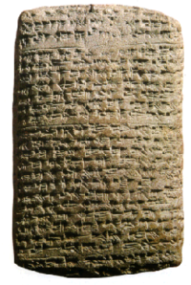
Although most residents seem to have abandoned Amarna with the royal court, some evidence exists to suggest that the Workmen’s Village remained occupied during Tutankhamen’s reign. Early excavators also discovered remains of “squatter activity” in additions to buildings. In fact, “a few pieces of inscriptional evidence relating to later kings has been found in the Central City and Main City; namely, pieces of a statue base and sculpted slab naming Horemheb and Seti I; a faience plaque of Horemheb; and a scarab of Ramesses II” (Stevens 2006: 14). Further evidence shows a later Roman settlement at the site. The city, then was not completely abandoned, but, rather, its importance as a capital was lost. Usually, collapse “entails the dissolution of the centralized institutions that created and defined relations of control and dependency between political centers and subjugated territories” (Sinopoli 1994: 168). Certainly, in the case of Amarna, the city collapsed due to the deaths of Akhenaten and his successor Smenkhare, who likely attempted to follow Akhenaten’s religious ideas. Though activity at Amarna after the death of Akhenaten shows that a settlement may have continued to exist there, the remains left by later pharaohs likely marked expeditions to quarry building materials from the site. Therefore, though a few squatters may have continued to live at Amarna, its population was significantly diminished, and its power and strength completely lost, showing that Akhenaten’s revolutionary ideas were drastic but temporary.

Truly knowing what was going on in Akhenaten’s head when he moved the Egyptian capital from Thebes to Amarna is impossible to know. But his intent was clear: to create a utopia that provided open worship for the Aten, the one true god in which he believed. The fanciful tale he described on his boundary stelae of the founding of the city as well as the artistic and architectural changes he instigated are the closest means to which we can understand the most interesting pharaoh in Egyptian history. Analysing the affect of Akhenaten’s actions at Amarna through the excavation of material culture has shed insight on the daily life of citizens at Amarna, suggesting that texts written in later times debunking the heretic pharaoh’s actions, as well as inscriptions composed by Akhenaten himself portray a skewed view of Egyptian life under his reign. The study of urbanism at Amarna shows that although Akhenaten’s religious upheaval may have had lasting effects on Egyptian government and society, its impact on daily life in general was less significant. Only further archaeological work can help to better explain the Amarna period, and the study of Akhenaten’s city is the only tool we have left to better understand the pharaoh and his subjects who lived there.

Works Cited
Bomann, Ann H.; 1991. The Private Chapel in Ancient Egypt. London and New York: Kegan Paul International.
Favro, Diane; 1994. “The street triumphant: the urban impact of Roman triumphal parades” in Streets: critical perspectives on public space. Zeynep Celik et al. (eds). University of California Press: Berkeley, 151-164.
Joffe, Alexander H.; 1998. “Disembedded Capitals in Western Asian Perspective” in Comparative Studies in Society and History, Vol. 40 No. 3. Cambridge: Cambridge University Press, 549-580.
Murnane, William J. and Charles C. Van Siclen III; 1993. The Boundary Stelae of Akhenaten. London and New York: Kegan Paul International.
Shaw, Ian; 1994. “Balustrades, Stairs, and Altars in the Cult of the Aten at el-Amarna” in The Journal of Egyptian Archaeology, Vol. 80. JSOTR, 109-127
Shaw, Ian; 1996. “Akhetaten: The City of One God” in Royal Cities of the Biblical World. Edited by Joan Goodnick Westenholz. Jerusalem: Bible Lands Museum, 83-109.
Shaw, Ian; 1998. “Building a Sacred Capital” in Capital Cities. Edited by Joan Goodnick Westenholz. Jerusalem: Bible Lands Museum, 55-64.
Sinopoli, Carla M.; 1994. “The Archaeology of Empires,” in Annual Review of Anthropology, Vol. 23. Ann Arbor, Michigan: University of Michigan, 159-180.
Stevens, Anna; 2006. Private Religion at Amarna. Oxford: Archaeopress.
Trigger, B.G. et al; 1983. Ancient Egypt: A Social History. Cambridge: Cambridge University Press.
Yegul, Fikret; 1994. in “The street experience of ancient Ephesus,” in Streets: critical perspectives on public space. Zeynep Celik et al. (eds). University of California Press: Berkeley: 151-164.
Webmoor, Timothy; 2005. “Mediational techniques and conceptual frameworks in archaeology. A model in ‘mapwork’ at Teotihuacán, Mexico” in Journal of Social Archaeology 5(1): 52-84.

