Are Exotic Plant Invaders All That Bad?
A research project investigating the effects of aquatic invasive exotic species in the Indiana Dunes in comparison with native species that form monocultures
Part I: The Problem with Exotic Species
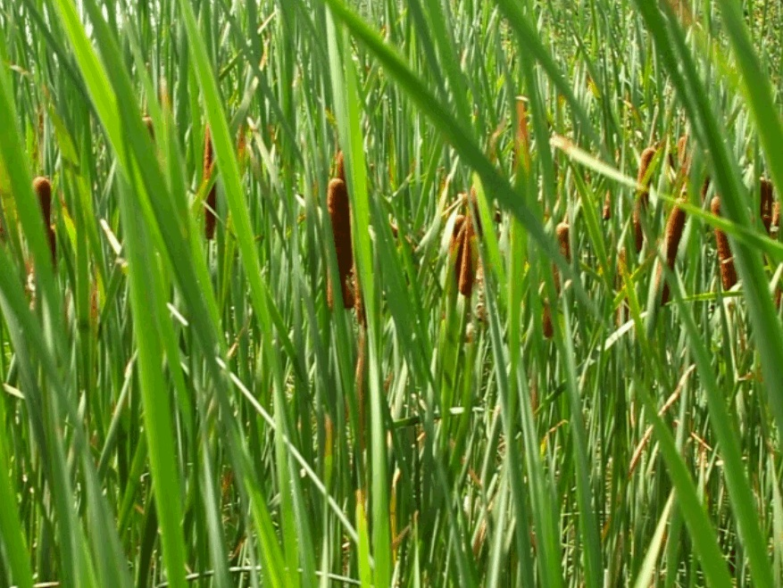
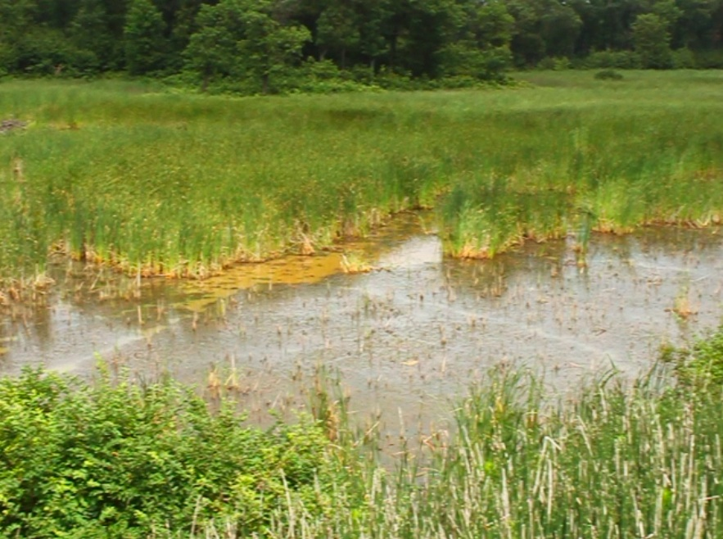
Exotic species plants, also called alien, introduced, or non-indigenous species are thought to be a leading cause of biodiversity loss in many aquatic ecosystems. According to the Environmental Protection Agency exotic species are non-native plants or animals deliberately or accidentally introduced into a new habitat outside of the habitats where they evolved. Once introduced to a new habitat, exotic species are able to reproduce and survive often unhindered by competitors or predators.

This is Typha x glauca, also known as a cattail, which is an exotic invasive species in the Indiana Dunes, and one of the species Lee was interested in studying. Typha x glauca is actually a hybrid between two other species of cattail- Typha angustifolia (figure a) and Typha latifolia (figure b).

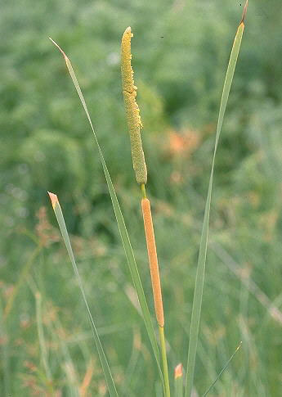
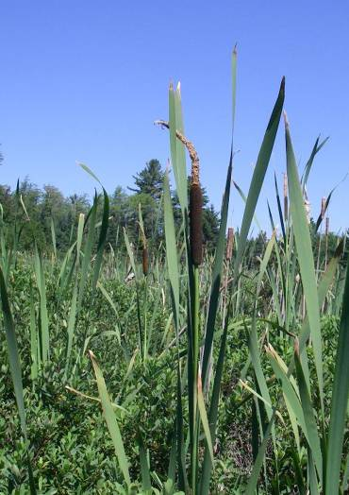
Figure b: Typha latifolia is native to the Indiana Dunes, but Typha angustifolia is not. Typha x glauca is considered an invasive exotic species, meaning that not only was it not normally found here, but once introduced it disrupts the ecosystem by spreading aggressively with very few natural predators to hold it back.

Figure a: Typha angustifolia Figure b: Typha latifolia

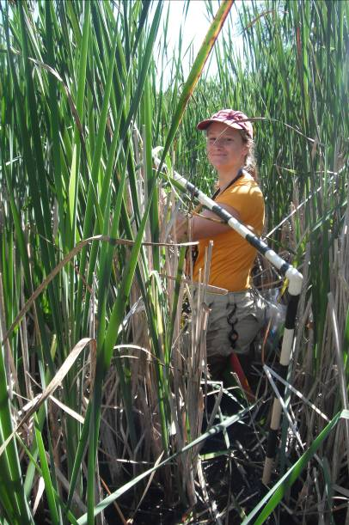

When Typha angustifolia arrived here to the ponds where Typha latifolia lived, the two cattails shared enough genetic material to interbreed, and a new hybrid was born, which is the cattail we see here. Today, virtually all the cattails that we see around us are the new hybrid. Armed with the traits from both parents,

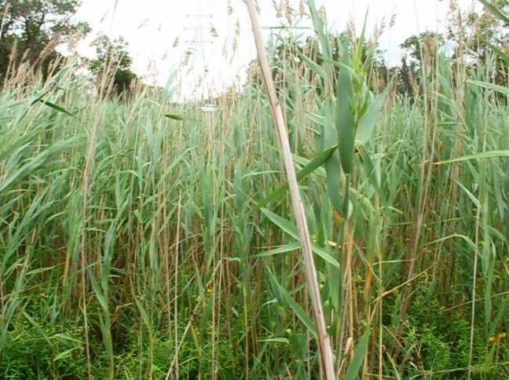

Phragmites australis, or common reed, is another exotic invasive plant species in the Indiana Dunes. A relative of Phragmites was native to our country, but the type from Europe is so similar to its American cousin that it can be only distinguished by DNA testing. It is also unique because it secretes gallic acid, which is broken down by UV light from the sun into mesoxalic acid. The combination of these two toxins proves to be a deadly mix for young plants trying to get started in the wetlands.
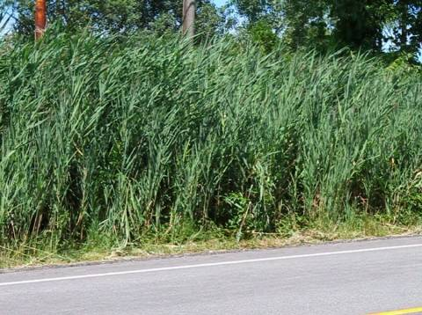
The European common reed is one of the biggest invaders into urban wetlands because it thrives in the high salt concentrations where humans salt the roads in winter.
Both Typha x glauca and Phragmites australis grow in dense patches, or stands, in wetland areas. As the patch spreads it blocks out sunlight for other plants in the area forming what could be called a monoculture, which is an area where one species dominates. In addition to space and light, Typha and Phragmites also monopolize nutrients that other organisms need to survive. All of these resources can be called limiting factors, and these resources become more limited at higher population levels. For example, ten individuals need more food, water, and other resources than one. This is called density-dependence.
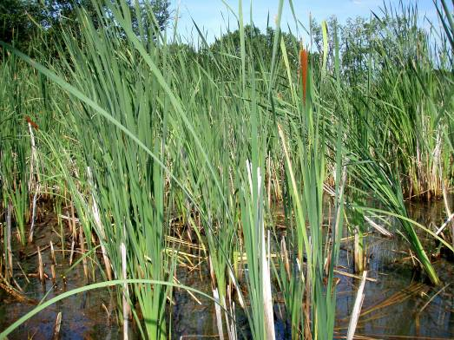

In this plot, a closer look would reveal that there are some plants at or just below the water’s surface that have managed to survive, but for how long?

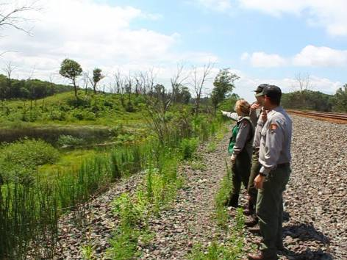
Most park management officials and conservation biologists believe that an exotic invasive species like these cattails cause problems by displacing native species through competitive exclusion. Some native species can even go locally extinct. There is plenty of research going on to show how exotic invasive species replace native species in ecosystems. However, there are plants that are native in the Indiana Dunes pond system that form dense stands a lot like the exotic invaders! Examples of native species that form resource depleting monocultures are Cephalanthus occidentalis and Schoenoplectus acutus.
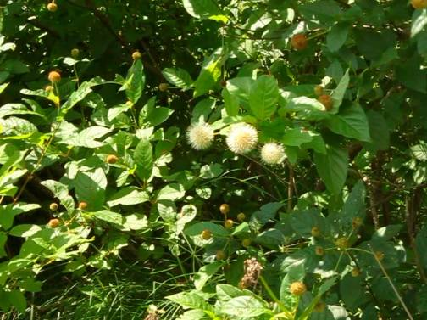
This is Cephalanthus occidentalis, known as buttonbush. It gets its name from these button-like flowers. Buttonbush is a native plant that forms dense patches in the wetlands of the Indiana Dunes too!

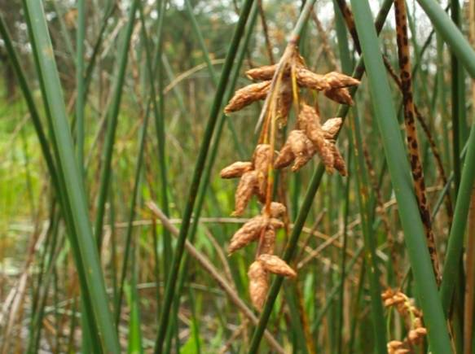

Schoenoplectus acutus, or hardstem bulrush, is another native species growing in these dense stands and shading out sunlight from the plants beneath.

Why aren't park managers worried about these species taking over wetlands too? Though they form dense patches, buttonbush and bulrush don't reproduce or spread as rapidly as an invasive species so the patches are smaller and fewer. Even so, these dense patches do seem to have a way of taking over the resources of an area and don’t seem to let much of anything else grow there.
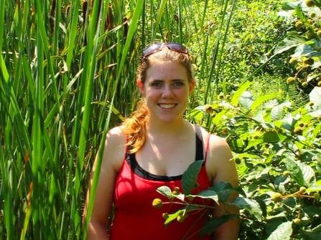
So why doesn’t anyone want to chop these down? If native species can form dense stands that deplete the community of limited resources just like exotic species, why do we try to destroy the exotic species but not the native species? Aren’t the native species just as bad?
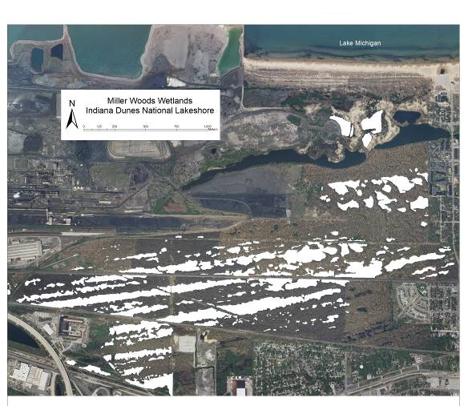
To find out, Lee Stevens a student at Brown University in Providence, RI majoring in Biology, traveled to Indiana Dunes National Lakeshore during the summer between her junior and senior years. Lee designed her research around comparing the effects of the exotic species and the native species we've just learned about on their immediate environments in the Miller Woods pond system, and the plants that live in them to provide a better understanding about the way local species extinctions are caused by invasives.
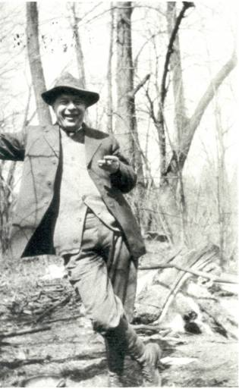
The Miller Woods ponds are a valuable place for research because we have accumulated a lot of information about them from research over the years. For example, we know exactly which species were growing in some of these ponds over thirty years ago! This amount of available data is why many scientists, like Lee, choose to do research here. The Miller Woods are home to 150 ponds that are the last remnants of a once- extensive pond system. The ponds formed in rows as Lake Michigan receded to the North after glaciers started melting 15,000 years ago.

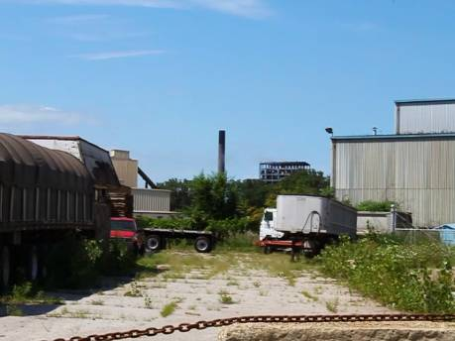
Although ecologists like Henry Cowles reported upwards of 50 rows of ponds in the area in the early 1900s, only a few remain today with the rest having been taken over by industry and housing.

Part II: The Research Project: Exotics Verses Natives
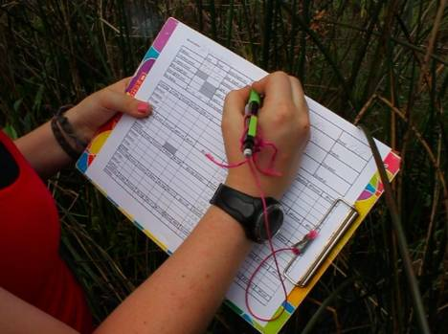
The competitive exclusion principle tells us that when two species occupy the same niche, in the same habitat, at the same time, they will compete until one becomes locally extinct. After all, there are only a limited amount of resources like sunlight and nutrients available to go around, and if the invasive exotics aren’t sharing, someone’s going to suffer!
Lee wanted to find out if these exotic "bad guys" were really all that bad. As you've already seen, some native species have similar effects on the ecological community; so Lee began to compare the two groups.
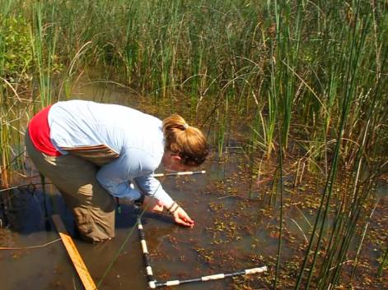
First, she found ponds that had large patches of the target species. She marked out areas within these patches of equal size, called quadrats, and counted the varieties of other plant species that were found growing it to see if the invasive species caused a decrease in biodiversity.
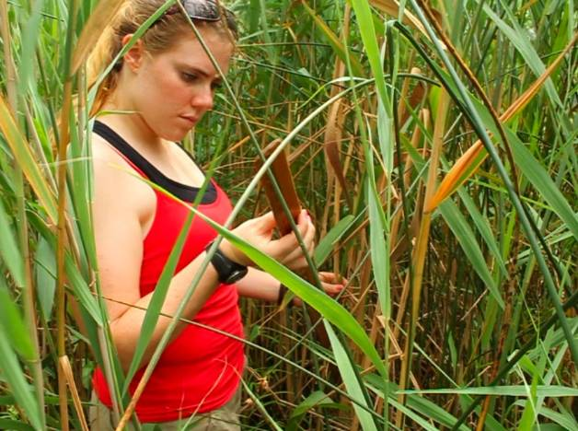
She also recorded the quality of health of some species to see if buttonbush, bulrush, cattails, or common reed changed how well other plants were doing. To measure health, she compared each species' biomass, which was estimated by recording the number of plants, how tall they were, and the size of their leaves. This helped to determine if plants had enough resources to allow them to grow.

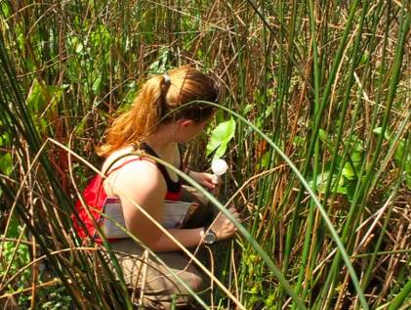
She also recorded if the plants were flowering or seeding, which are signs of reproduction. If plants in an area are reproducing, it shows that they are biologically fit. Their ability to produce viable offspring means they are passing their genes on to the next generation.
To measure resources that might be limiting plant growth, she also recorded the amount of light reaching the water surface with a light meter. Since light is a limiting factor for all plants, the amount of light that is able to reach through the dense stand can be an important factor that determines the health of those that are able to survive.

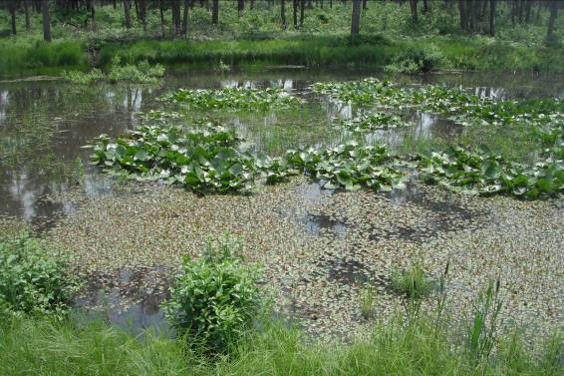
Since all scientific experiments need to have a control group as a basis of comparison, she recorded the same measurements in areas free from dense patches of tall plants. There she could see how the plants would grow if these populations didn't block out the sun or take up other limiting resources, and show even more similarities and differences between the exotic plants and the native monoculture species.
What do you expect to see in the results when we compare the native monoculture quadrats to the exotic species quadrats? Do you think the areas in the native species patches will have higher biodiversity and healthier plants than those found with exotic species quadrats, or the opposite? Why? How will the native and exotic patches compare to the relatively open areas?

Part III: Results and Concern for the Cost of Solutions
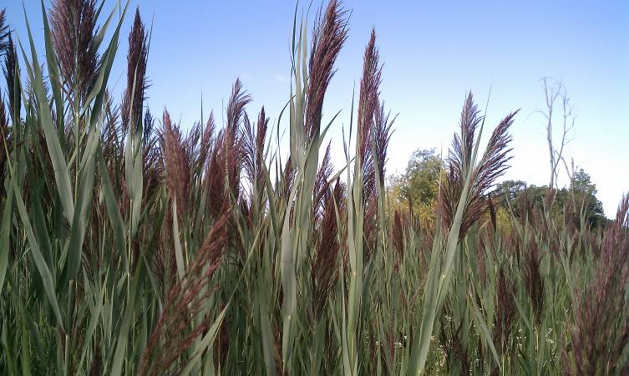
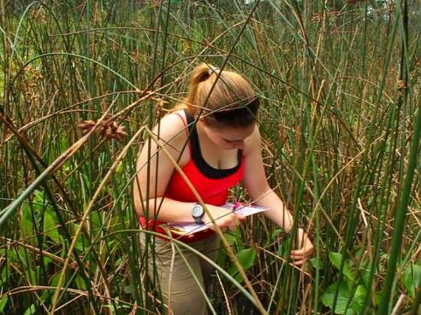
We’ve been looking at how competition for limiting resources can cause competitive exclusion of native species, potentially leading to their local extinction. That’s why most park management officials and conservation biologists believe exotic invasive species like this Phragmites australis should be eradicated. Perhaps Lee’s research might help to better understand the effects exotic invasive plants on the communities around them when compared to the effects of native monoculture plants.

Overall, Lee found that biodiversity, biological fitness, and general health of the plants growing any patch type were lower than the control groups. However, in addition to how each patch types affect other species, we have to consider how MANY patches and how BIG they are!
Conservation biologists aren’t going to be as concerned about a species that is only in a few spots. The plant with the largest number of patches was Typha x glauca and each patch covered a lot of area.
That means that based on the area of the ponds affected, cattails had the biggest impact other species by using the most limiting factors.
There were slightly fewer stands of Phragmites australis, the other exotic invasive tested, and each took up a little less space in the ponds. Both exotic species had far more patches than Cephalanthus occidentalis and Schoenoplectus acutus.
While Schoenoplectus stands still consumed important resources, there were very few stands of in the ponds and these stands were the smallest.
Therefore, while all four of the species tested had a negative impact on the species growing around them, the exotic invasive species really do take up more limiting resources than the native species when we consider the whole area of Indiana Dunes.
The study's unique contribution to conservation biology is that it compares how four plant species cause different amounts of competitive exclusion and local extinction. The next step is to inform Park Management of the findings so they can use the data to help decide which patches of invasive exotics are worth the cost of removing. After all, it isn’t' easy to get rid of these plants once they have taken over an area.
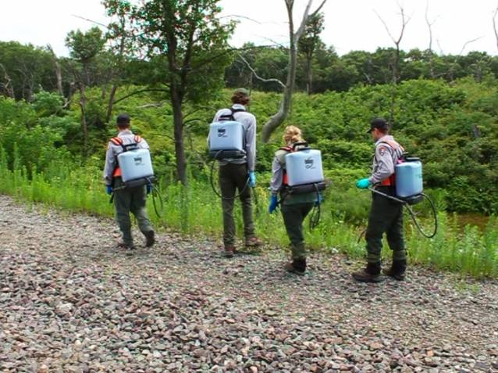
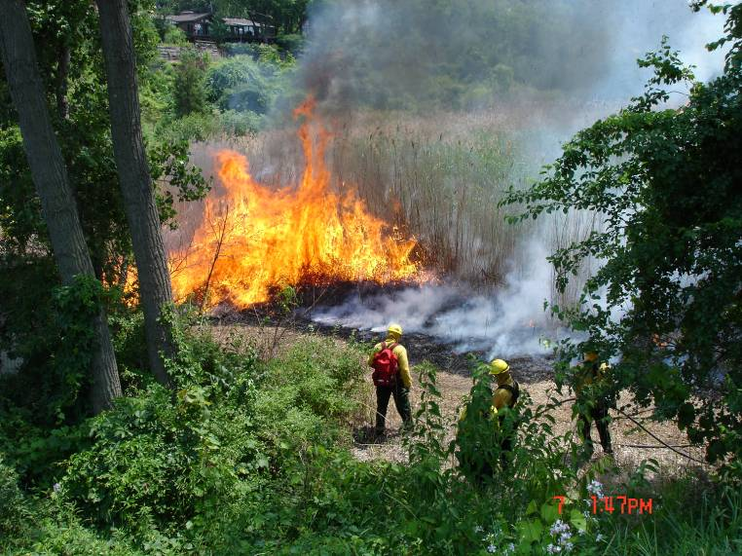
Native species could recolonize any area where exotics were removed. However, we often need to help them get started, and monitor the area for exotic regrowth. The real issue is balancing the limited resources that we have for exotic removal. Clearly, if we're going to remove these species at all, we need to be choosy about where to do it, and to what extent. Data from previous research shows that these exotic species weren't here as little as 30 years ago, or at least they weren’t a problem- but today they're everywhere we look. If they aren't spreading to new areas, then maybe we can leave them alone. But can we take the risk? What about the fact that the Miller Woods ponds within the Indiana Dunes are the last remnants of the Calumet Lake Plain? Isn't there some historical value worth keeping the ponds biodiversity and pre-human state? But at what cost? These are all big gaps for ecologists to fill, and good examples of how the answers aren't always straightforward in science.

The best way to get rid of Phragmites is to burn it 2-3 years in a row. Their roots are so strong and grow so deep that burning them one time is never enough; they would just grow back the next year.

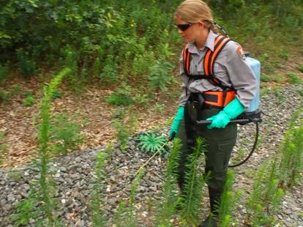
Many of the things we use to remove plants we don't want, such as fire or toxic chemicals, require workers with special skills and expensive equipment. Many of the wetlands you see along roads, like this one, are overrun with exotic invasive species. Should resources and the difficult physical labor needed to eradicate the exotic invaders be used everywhere, or only in places like parks? It gets tricky.

Hopefully Lee’s research has helped you to learn a little bit more about invasive exotic species in the wetlands, and how they are limiting the availability of resources that other plants in the community need to survive and reproduce. Thanks for following along!


