Field Experience:
Extracting a Sediment Core
Part 1- Pre lab questions

Name:______________________________________Date:_______________Class:________________
- Why do ecologists use sediment cores?

- Define macrofossil.

- What 2 factors make using the rate of sediment accumulation an unreliable method of determining the age a macrofossil? Explain.

- Describe relative dating.

- How did the Miller Woods ponds form?

- Why are there fewer ponds today than when Henry Cowles began to research the plant communities of the Miller Woods?

Extracting a Sediment Core
Part 2- Sediment Sample Analysis Data Collection

Name:______________________________________ Date:_______________Class:________________
Objective: Collect data from the most recent cores taken from the Miller Woods ponds. Use an interactive web site that allows you to zoom in on the actual macrofossils found by researchers from Brown University.

Go to the Online Core Sample: http://coolhub.imsa.edu/web/core-project/core-sample
- Use the attached macrofossil key to identify macrofossils found in the sediment core at various depths.
- Complete the data table by indicating how many of each plant species was present at that depth.
- Put a check mark in the appropriate box if Ambrosia pollen or Industrial Particles were found

Sediment Sample Data Table #1
Sample types | Core Depth (cm)
Sample types | 2-4 | 4-6 | 6-8 | 8-10 | 10-12 | 12-14 | 14-16 | 16-18 | 18-20 | 20-22
Brasenia
schreberi
Cyperaceae-trigonous
Cephalanthus occidentalis
Eleocharis
sp.
Nuphar
advena
Polygonum hydropoperoides
Proserpinaca
Palustris
Quercus
leaf
Scirpus
sp.
Typha
sp.
Industrial
particles
Ambrosia
pollen

Sediment Sample Data Table #2
Sample types | Core Depth (cm)
Sample types | 22-24 | 24-26 | 26-28 | 28-30 | 30-32 | 32-34 | 34-36 | 36-38 | 38-40 | 40-42
Brasenia
schreberi
Cyperaceae-trigonous
Cephalanthus occidentalis
Eleocharis
sp.
Nuphar
advena
Polygonum hydropoperoides
Proserpinaca
Palustris
Quercus
leaf
Scirpus
sp.
Typha
sp.
Industrial
particles
Ambrosia
pollen

Data Analysis Questions:

- Ambrosia was actually in the area long before the industrial revolution. Why did Ambrosia pollen sharply increase during the same time that industrial particles began appearing in the sediment?

- Describe the changes in the Scirpus sp. population over time.

- Describe the changes in the Proserpinaca palustris population over time.

- Based on this sediment core what two plants seem to have disappeared from the pond community? What could have caused these losses?

- Predict what plants would be growing in the pond today in the sediment.

Key for Macrofossil Types
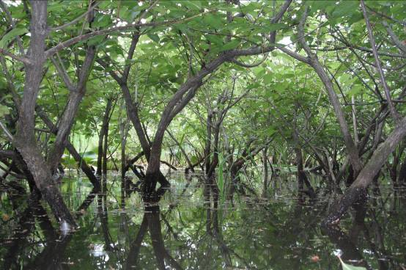
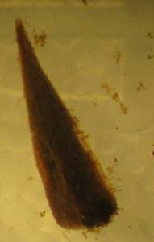
Scientific name: Cephalanthus occidentalis
Macrofossil group: Cephalanthus occidentalis
Common name: Buttonbush
Origin: Native
Notes: Emergent dicot shrub
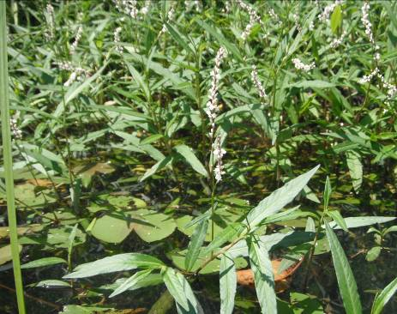
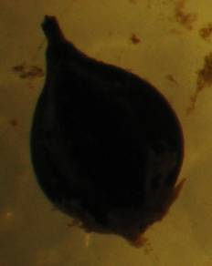
Scientific name: Polygonum hydropiperoides
Macrofossil group: Polygonum hydropiperoides
Common name: Swamp smartweed
Origin: Native
Notes: Emergent dicot herb

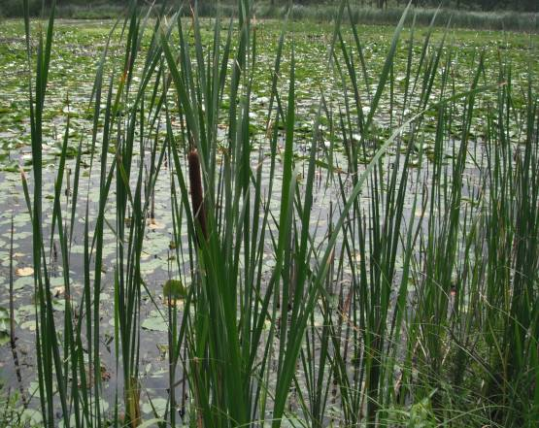
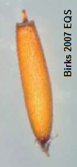
Scientific name: Typha x glauca
Macrofossil group: Typha
Common name: Hybrid cattail
Origin: Hybrid between native and exotic cattails
Notes: Emergent monocot herb

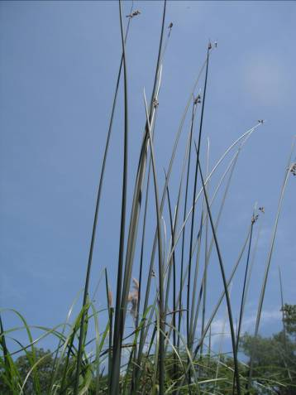
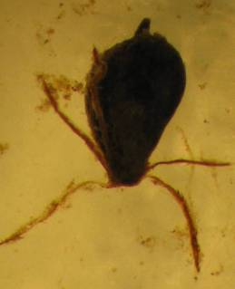
Scientific name: Scirpus acutus
Macrofossil group: Scirpus
Common name: Hardstem bulrush
Origin: Native
Notes: Emergent monocot herb

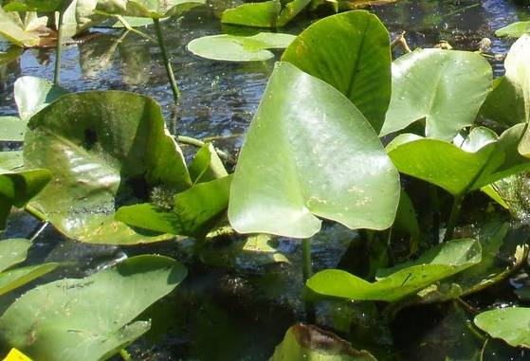
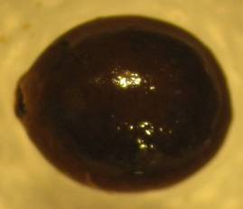
Scientific name: Nuphar advena
Macrofossil group: Nuphar
Common name: Yellow pond-lily
Origin: Native
Notes: Floating or emergent monocot herb

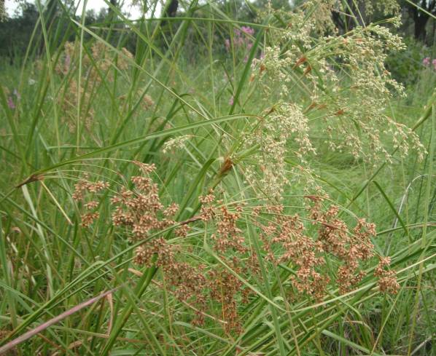
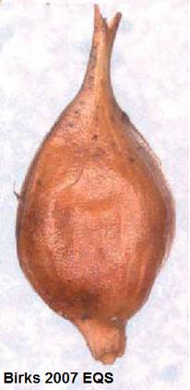
Scientific name: Cyperaceae
Macrofossil group: Cyperaceae trigonous
Common name: Sedge family
Origin: Native
Notes: Emergent monocot herb

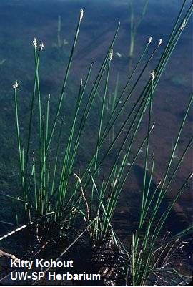
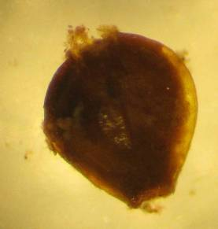
Scientific name: Eleocharis palustris
Macrofossil group: Eleocharis
Common name: Common spikerush
Origin: Native
Notes: Emergent monocot herb

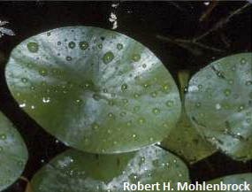
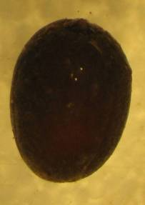
Scientific name: Brasenia schreberi
Macrofossil group: Brasenia schreberi
Common name: Watershield
Origin: Native
Notes: Floating dicot herb

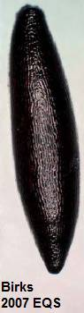
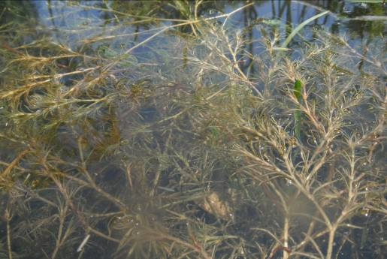
Scientific name: Najas flexilis
Macrofossil group: Najas flexilis
Common name: Slender water-nymph
Origin: Native
Notes: Submerged monocot herb

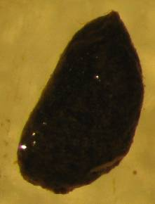
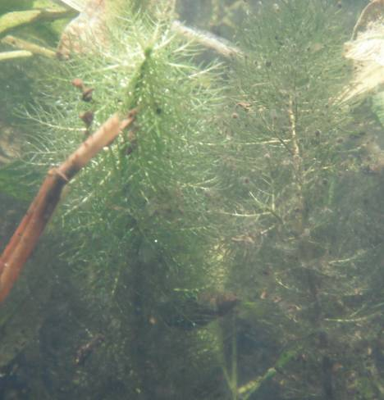
Scientific name: Myriophyllum verticillatum
Macrofossil group: Myriophyllum
Common name: Whorled milfoil
Origin: Native
Notes: Submerged dicot herb

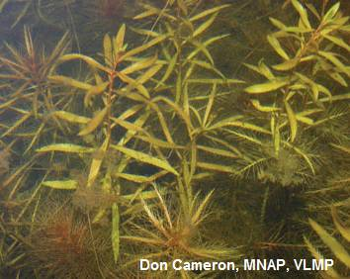
Scientific name: Proserpinaca palustris
Macrofossil group: Proserpinaca palustris.
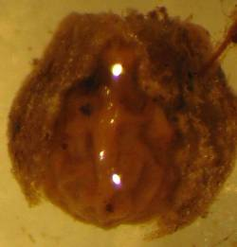
Common name: Marsh mermaidweed
Origin: Native
Notes: Submerged and emergent dicot herb

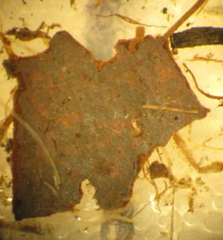
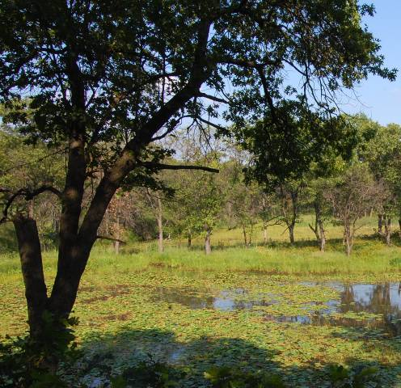
Scientific name: Quercus velutina
Macrofossil group: Quercus species
Common name: Oak
Origin: Native
Notes: Dicot tree
Field Experience
Extracting a Sediment Core
Part 3- Analyzing a Sediment Sample

Name:_____________________________________ Date:_______________Class:________________

Objective:
In a hands-on session, your team will dissect a model section of a sediment core to determine the relative age of the macrofossils found within using the data collected from the online portion as a guide. Overall analysis of the core also reconstructs a history of the plant community of the pond for a better understanding of human impacts on plant succession.

Materials per team:

Core Collection Materials:

Bulb planter (preferably with spring loaded handle See Figure 1)
Pitcher
Tarp: 50cm x 50cm (approx.)
Dowel Rod: 15cm (approx.)
Plastic wrap
Aluminum Foil
Metric Ruler
Duct tape
Sharpie Marker
Journal
Materials Bin
Poster tube 15 cm – 20 cm (approx.)

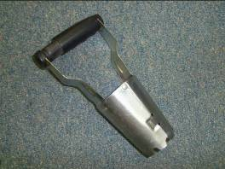
Figure 1: Spring loaded bulb planter

Procedure:
- Set up a station on the shore to store the core for later by laying the tarp in a flat area. Place the materials bin next to the tarp.
- Take the pitcher and bulb planter to the collection site.
  - At the collection site, push free leaves and debris away to expose the sediment at the bottom.
- Use the Bulb planter to collect a sample of the sediment.

  - Twist to the right then to the left on the handle of the bulb planter as you press down into the sediment layer of the core site. If the bulb planter has a button on the handle, press the button in while pushing down to widen the opening at the bottom of the planter. Be careful not to disturb the layers of the sediment as you twist.
  - Pull up on the bulb planter slowly to remove your sample. Prevent the sediment from falling out by use your hand to cup the sediment at the bottom. If your bulb planter has the button on the handle, pull and hold the button out as you slowly lift the planter out to tighten the bottom and help keep the sample inside the planter.
  - Put the bulb planter containing the sample into the pitcher and move it to the tarp on shore.
- Extract Core and Record Observations

- Lay out a layer of aluminum foil on the tarp that will be long enough to wrap around your core sample (at least 15 cm long).
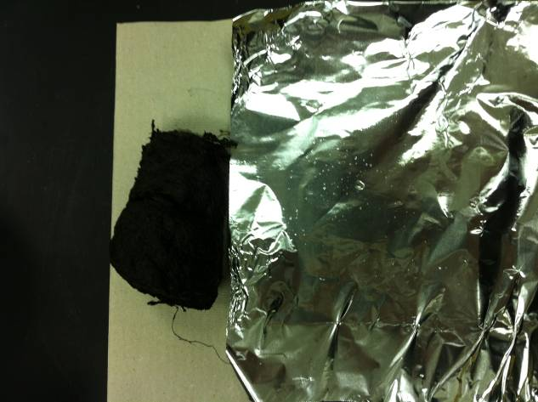
  - Repeat with a layer of plastic wrap on top of aluminum foil.
  - Use the dowel rod to gently push the core onto the layer of plastic wrap.
  - Record observations in your journal including length of core, observable layers, areas of unconsolidated (loose) or consolidated (tightly packed) sediment, soil types visible, debris, etc. Use the ruler to note where on the core these observations can be found marking the top of the core as 0cm.
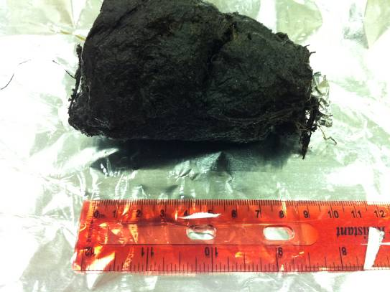

- Mark the end of the core then store it for later.

  - Place a small piece of balled up foil at the bottom of the core as a marker.
  - Wrap the core in the plastic wrap carefully, without disturbing its shape or size.
  - Repeat with the aluminum foil.
  - Use a piece of duct tape to close the aluminum foil, then label the duct tape with an arrow toward the top of the core and any additional information to identify the core # or team, etc.
  - Gently push the wrapped core sample into the poster tube segment for storage.
  - Finally. Label a piece of duct tape on the poster tube with the same identifying information that was used on the inside label including the arrow toward the top of the core. Place duct tape over the ends of the poster tube to prevent the sample from sliding out.

Core Processing Materials:

1 per core:
Calculator Tape
Metric Ruler
Clay Cutting Wire or knife
Cutting board
A few can be shared among several teams:
Spatula or wooden tongue depressor
250 um filter
Narrow mouth wash bottle

1 per cm of core (team):
Dissecting Microscope
Sample Bottle with lid
Probe
Petri dish

Wax pencil

Procedure:
- Remove the core sample from storage and record observations.
  - Remove the duct tape from one end of the poster tube and slide the core sample out.
  - Unwrap the core sample on a clean, hard surface.
  - Lay a piece of calculator tape next to the sample from end to end and draw lines on the tape to mark the top and bottom of the core.

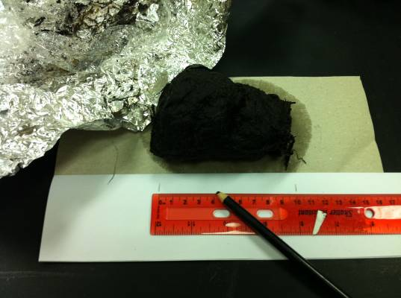
  - At the top end of the calculator tape, record all the information that was on the duct tape as well as today’s date and your team’s information.
  - Measure the core starting with 0cm at the top and record the length on the calculator tape.
  - Use the ruler to measure and mark each centimeter on the calculator tape from the top of the core to the bottom.
  - Record notes about cracks in the core, changes in soil type, etc. at the corresponding length on the calculator tape. Use your notes from core collection to help.
- Cut the core sample into 1 cm segments
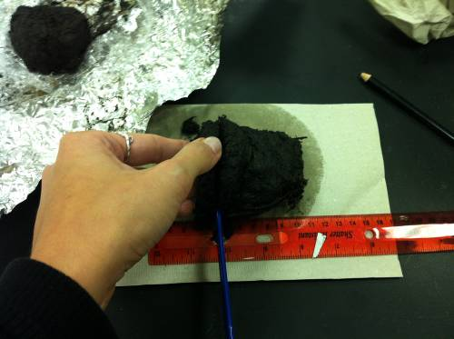
  - Place the ruler nestled next to the core so that the metric measurements are easy to read next to it with 0 cm at the top of the core.
  - Use a spatula or wooden tongue depressor to gently mark 1cm – 5 cm.
  - Use a clay cutting wire or knife to carefully cut the core straight down at the 1 cm mark. Slow, short saw motions will help prevent the core from breaking apart. Try to keep the portion that is being cut away in one “cookie” piece.
  - Carefully move the segment onto a cutting board and lay it flat.
  - Use the spatula or wooden tongue depressor to scrape away the perimeter edge of the segment to remove contaminants from the edge of the sample.
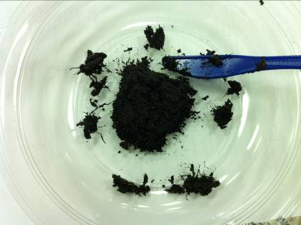
- Prepare segment for viewing

  - Rinse the spatula or wooden tongue depressor, and then use it to move the segment into the filter.
  - Use the narrow mouth wash bottle to rinse particles smaller than 250um through the filter. Avoid damaging important fragments by being careful not to drag the particles onto the filter mesh.
  - After all small particles have been rinsed through the filter, use the wash bottle and spatula to move the larger pieces into the storage bottle.
  - When all particles have been moved into the storage bottle, fill it with the water from the wash bottle to the top and close the lid.
  - Finally, use the wax pencil to mark the side of the storage bottle with important team information as well as today’s date.
  - Clean up.

- View the sediment with the dissecting microscope.

  - Open your team’s storage bottle and pour enough of the sediment onto the petri dish to cover the bottom.
  - Move the petri dish to the dissecting microscope use the probe to work through the sediment looking for plant segments such as leaves, stems and seeds.
  - Record observations in the team’s journal.
  - When the observation period is over, clean up your area and dispose of sediment materials as instructed by your instructor.

Post Lab Questions:

- How do you think that this is similar to the way scientists collect sediment cores from ocean and lake floors? How is it different?

- Was your group able to identify any macrofossils in your core? If so, what were they?

- Explain why it is important to wait several decades between extractions of sediment core samples.

- What are the benefits of identifying macrofossils from different time periods in an area?

- What has caused the plant communities of the Miller Woods ponds to change over the course of the past 30 years?

