Sediment sample analysis
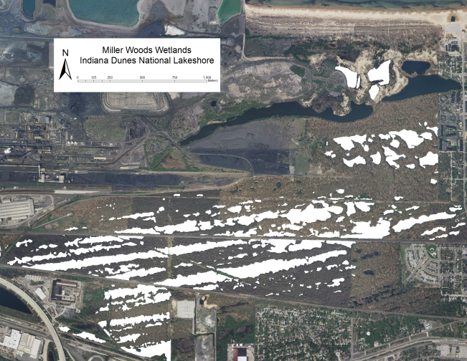
Part 1- Background
Why the Miller Woods?
The Miller Woods (pictured in white on the right) are home to >150 ponds that are the last remnants of a once extensive pond system. The ponds formed in long rows as Lake Michigan retreated north as the glacier covering North America repeatedly melted and stalled starting 15,000 years ago.
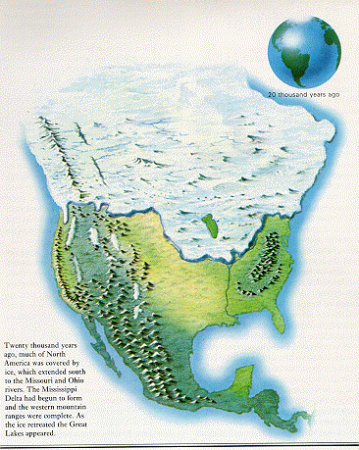
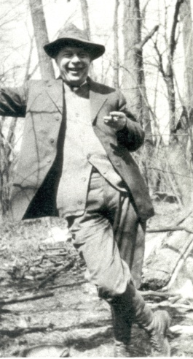
The Miller Woods ponds are a valuable place for research because so much information about them has been accumulated over the years. Henry Cowles, the ecologist pictured on the right for which Cowles bog is named, reported upwards of 50 rows of ponds in the area in the early 1900s. Today only a few remain with the rest having been taken over by industry and housing. However, the ponds still contain many unique communities of plants and animals.
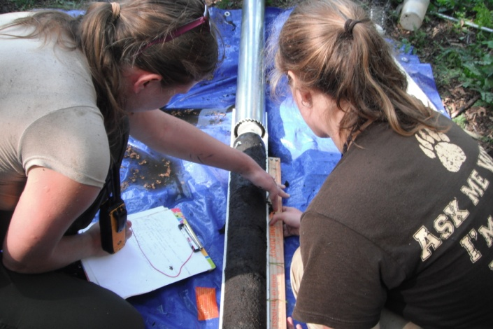
During the summer of 2011, the ponds were cored by a research team from Brown University (pictured on the left) to learn about how and why the species found in the pond plant communities had changed since industry had taken over the area. The more we learn about what caused past changes, the more we can protect the ponds from future changes.

In this set of activities we will use the data from one of the cores to find out how relative dating works. We’ll also compare the species that lived there through time to those that live there today and ask if there is a connection to these changes and the spread of human development.
What is a sediment core?

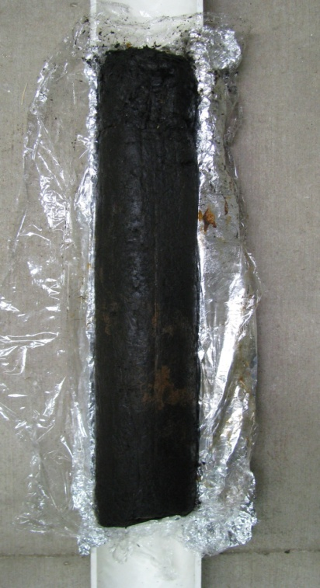

A sediment core is a tube of sediment collected from the bottom of a body of water. The core is then sliced to reveal preserved evidence of organisms that lived as the sediment was formed. The depth of the core is used to determine the relative age of the specimens found since younger fossils are usually found in layers above older fossils. (Figure A) Relative dating of fossils doesn’t give information about actual age of the fossils but it does allow researchers to understand how the ecological community changed over time. In this activity we will assume that the sediment length increases 45.5 mm per year. Therefore, 1 cm of core length = 22 years of sedimentation.

← Top of Core

← Younger macrofossils are found at higher levels

← Since deeper layers settled first, macrofossils found deeper are older than those found at higher levels.

← Bottom of Core

Figure A: Sediment Core from Miller Woods

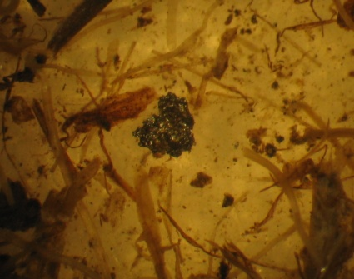
We can find evidence of human activities in cores, such as the metal particle in the image to the left. By identifying macrofossils throughout the core, it is possible to tell which plants were present when each sediment layer was formed. A macrofossil is a preserved leaf, seed or other plant segment useful in identifying the plants growing in the area during that time period. Macrofossils are different from plant microfossils, such as pollen, which can only be seen with a very strong microscope.

Part 1 review - Pre lab questions

Name:______________________________________Date:_______________Class:________________
- How did the Miller Woods ponds form?

- Why are there fewer ponds today than when Henry Cowles began to research the plant communities of the Miller Woods?

- Pick one and write a hypothesis:
  - How have the plant communities of the Miller woods changed over the course of the past 300 years?

  - What has caused the plant communities of the Miller Woods ponds to change over the course of the past 30 years?

- Define macrofossil?

- Which sediment layer contains the older macrofossil: one found 17 cm deep or one found 12 cm deep? Explain.

- If a sediment core is 4 centimeters long, how many years of sediment does it contain?

Part 2- Sediment Sample Analysis Data Collection

Name:______________________________________Name:__________________________________
Name:_____________________________________ Date:_______________Class:________________
Objective: In this activity, we will collect data from the most recent cores taken from the Miller Woods ponds. We will use an interactive web site that allows you to zoom in on the actual macrofossils found by researchers from Brown University. Later we will use this data to analyze a segment of a model sediment core.

Go to the Online Core Sample 2: http://coolhub.imsa.edu/web/core-project/core2
- Complete the data table by indicating how many of each plant species was present at that depth.
- Put a check mark in the appropriate box if Ambrosia pollen or Industrial Particles were found

Sediment Sample Data Table #1
Sample types | Core Depth (cm)
 | 2-4 | 4-6 | 6-8 | 8-10 | 10-11 | 12-14 | 14-16 | 16-18 | 18-20 | 20-22
Brasenia
schreberi
Cyperaceae-trigonous
Cephalanthus occidentalis
Eleocharis
sp.
Nuphar
advena
Polygonum hydropoperoides
Proserpinaca
Palustris
Quercus
leaf
Scirpus
sp.
Typha
sp.
Industrial
particles
Ambrosia
pollen

Sediment Sample Data Table #2
Sample types | Core Depth (cm)
 | 22-24 | 24-26 | 26-28 | 28-30 | 30-32 | 32-34 | 34-36 | 36-38 | 38-40 | 40-42
Brasenia
schreberi
Cyperaceae-trigonous
Cephalanthus occidentalis
Eleocharis
sp.
Nuphar
advena
Polygonum hydropoperoides
Proserpinaca
Palustris
Quercus
leaf
Scirpus
sp.
Typha
sp.
Industrial
particles
Ambrosia
pollen

Data Analysis Questions:

- How long ago did industrial particles begin to appear in the sediment? Show your work. (Hint: Remember that 1cm = 22 years).

- Why is it considered only a very rough estimate to say that 1cm of sediment formation equals 22 years?

- Why do you think Ambrosia pollen increased during the same time that industrial particles began appearing in the sediment?

- Describe the changes in the Scirpus sp. population over time.

- Describe the changes in the Proserpinaca palustris population over time.

- Based on this sediment core what two plants seem to have disappeared from the pond community? What could have caused these losses?

- Why do you think some macrofossils seem to disappear then reappear in the sediment core?

Part 3- Analyzing a Sediment Sample

Name:______________________________________Name:__________________________________
Name:______________________________________Date:_______________Class:________________

Objective: In a hands-on session, your team will dissect a model section of a sediment core to determine the relative age of the macrofossils found within using the data collected from the online portion as a guide. Overall analysis of the core also reconstructs a history of the plant community of the pond for a better understanding of human impacts on plant succession.

Materials per team:

Sediment Baggie
Sorting Plate
Identification Key Card
Data Table

Procedure:

- Empty the contents of your sediment baggie onto the sorting plate and begin separating macrofossils, pollen, and industrial particles from sediment.
- Use the Identification key card to determine which macrofossil, pollen or industrial particle each noodle and glitter color represents.
- Record the amount of each type of particle found in the sediment sample on the sample portion of your team’s data sheet.
- Compare the contents of your sample to the various levels of the actual core to determine which level of the core your sample represents.
- Clean up your area by returning materials to the baggie and putting all supplies away and answer the analysis questions.

Sediment Sample Data Table:

Sample #______________________________________
Macrofossil | Noodle/Glitter Representative | # Found | Macrofossil | Noodle/Glitter Representative | # Found
Brasenia  schreberi |  |  | Proserpinaca  Palustris
Cyperaceae-trigonous |  |  | Quercus  leaf
Cephalanthus occidentalis |  |  | Scirpus  sp.
Eleocharis  sp. |  |  | Typha  sp.
Nuphar  advena |  |  | Industrial  particles |  | Yes / No
Polygonum hydropoperoides |  |  | Ambrosia  pollen |  | Yes / No

Post Lab Questions:
- According to your results, from what depth was your sample taken?

- How were you able to determine the depth identity of your sample?

- Compare the depth of your sample to the depth of the other samples of the class. Put the lab groups in order according the age of their samples from oldest to youngest.

- Youngest Lab Group___________________________________________________________________

2. Lab Group _______________________________________________________________________________

3. Lab Group _______________________________________________________________________________

4. Lab Group _______________________________________________________________________________

5. Lab Group ______________________________________________________________________________

6. Lab Group ______________________________________________________________________________

7.Oldest- Lab Group ______________________________________________________________________

- How do you think that this is similar to the way scientists collect sediment cores from ocean and lake floors? How is it different?

- Predict what plants would be growing in the pond today in the sediment.

- Why are some plants present today but not found in the sediment?

