Part 1: The Temperate Deciduous Forest
Name:___________________________________Date:___________Class:_____________
In 1983 research was conducted (Wilcox and Simonin 1987) with results showing that as ponds age they become progressively more shallow. The results also indicated that while the plant species found within younger ponds are submersed, those that are in deeper, shallower ponds tend to be emergent.
In the summer of 2011 a new set of data was collected from the same Miller Woods ponds system to determine what had changed over the nearly 30 years since the previous study. This study questioned the driving forces behind these changes and examine how and why some ponds are somehow different from each other in terms of vegetative communities, meaning at different stages of succession, despite being approximately the same age and size.

The Miller Woods pond system is an excellent example of succession as communities in the area changed through time while Lake Michigan retreated northward. The area had gone predominately untouched by human progress until the expansion of the railroad system and eventually the development of the steel industry in the area tied closely with urbanization.

These introduced variables in the standard model of succession coupled with the prior research archive of a species catalog of the ponds make the Miller Woods ponds an ideal example of the true intricacies of the real world models of succession methods.
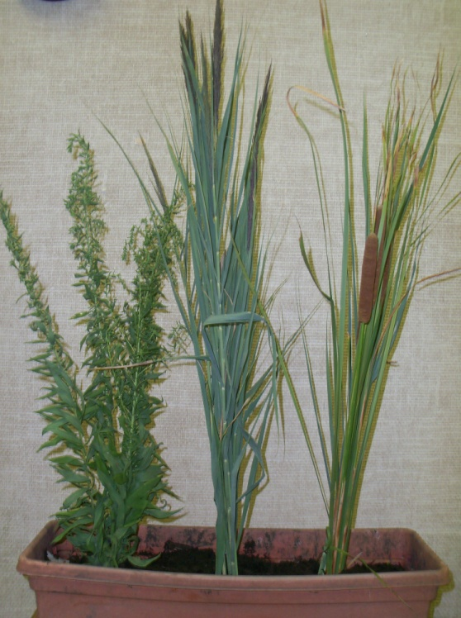
The plants to the left are examples of species that can be found in the Miller woods found in the Southern tip of the Great Lakes region. A large portion of the Great Lakes region is part of the temperate deciduous forest biome which can be distinguished from other biomes by key characteristics including seasonal temperature changes, year round precipitation, and deciduous trees that go dormant and shed their leaves in the fall to help them survive through the cold winter.
The name “temperate deciduous forest biome” can be misleading since the entire biome isn’t made up of forests. Biomes are made up of several ecosystems. For example, the temperate deciduous forest biome ecosystems include forests, prairies, wetlands, dunes and more. Within each ecosystem, multiple habitats are found which are areas inhabited by a particular species of organism. For example, a habitat includes the near shore sand for sand fleas found in the dunes ecosystem in the temperate deciduous forest biome.

1. List 2 examples of habitats found in the Great Lakes region. Don’t use the example that has already been given! Include 2 organisms that live in each.

Habitat: __________________________
Organism #1: ___________________
Organism #2: ___________________
Habitat: __________________________
Organism #1: ___________________
Organism #2: ___________________

Living things in the environment such as plants and animals are called biotic factors. This includes things that were once living such as the fallen leaves. Abiotic factors are nonliving portions of the environment such as soil, sunlight, temperature and water.
One important abiotic factor is soil. The soil found in the forest ecosystem of the temperate deciduous forest biome is rich in nutrients because of decaying material such as fallen leaves that is broken down into rich organic material called humus. This humus rich soil is also great at holding water, making it available for plant use. Nutrients and water are then available to support the producers of the food web, which in turn support primary consumers, which support secondary consumers and so on providing some areas of the temperate deciduous forest biome with a wealth of biodiversity. Conversely, nutrients and water are not held well in sand leaving the soil very poor for plant growth. Wetland soil is so wet that there is very little oxygen available for plants and bacteria. Dead plant material does not decay, leading to mucky sediment with lots of nutrient trapped in the old plant material.

2. Compare Biotic to Abiotic factors:
______________________________________________________________________________
______________________________________________________________________________
______________________________________________________________________________
3. Is the example Biotic (B) or Abiotic (A)

a. _________ Tree
b. _________ Water
c. _________ Seed
d. _________ Cloud
e. _________ Apple

4. Give examples of each

Abiotic factors:

a.________________________

b.________________________

c. ________________________

Biotic Factors

a. ________________________

b. ________________________

c. ________________________

5. A student tested soils from 3 ecosystems: Pond sediment, the prairie, and the forest.
- Which should have the most humus in the soil? Why?

______________________________________________________________________________
______________________________________________________________________________
- Which should have the least nutrients in the soil? Why?

______________________________________________________________________________
______________________________________________________________________________
EXTENTION: Research for Survival

Each organism each has a limited range of tolerance for abiotic factors in their environment. Since each ecosystem contains a different range of abiotic factors the creatures there must be adapted to survive those conditions or their species will go extinct.
For example, the creatures that live in in the arctic tundra are adapted to the cold and dry conditions and could not survive in the wetlands of the Great Lakes. If a group of cattail were taken to the tropical rainforest where the soil is nutrient poor, they may thrive for perhaps only a few seasons. Since the group died locally but more of the species exists on the earth, this is called local extinction.
- Research to find the human range of tolerance:
  - How many days can you go without food or water? _______________

  - What is your temperature range that you can survive? What if it was raining or you had no shelter?

___________________________________________________________________________

___________________________________________________________________________

- Research to find 5 examples of adaptations that species in your ecosystem need to survive.

Species |  | Adaptation
a.
b.
c.
d.
e.

- Research 2 species that have gone extinct in one area but are not extinct worldwide. Why did they go locally extinct?

Species |  | Reason
a.
b.

