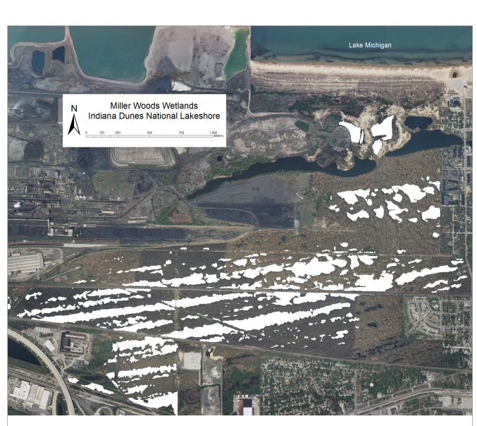
Sediment core Modeling
Part 1- Background Information:
Why the Miller Woods?
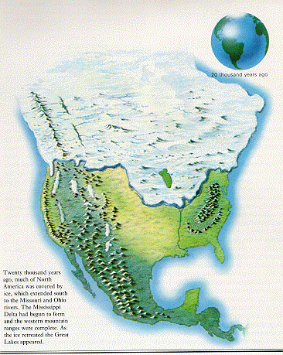
The Miller Woods (pictured in white on the right) are home to 150 ponds that are the last of a once very large pond system. The ponds formed in rows as Lake Michigan receded to the north after glaciers started melting 15,000 years ago.

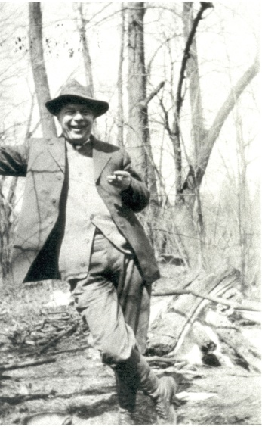
Each time the glacier (pictured on the left) stalled and then melted a new set of ponds were formed. Then the glacier retreated further north and stalled again repeating the process over and over. You can see that the ponds formed in long lines due to this process.

Although ecologists like Henry Cowles (pictured on the right) reported more than of 50 rows of ponds in the area in the early 1900s, only a few remain today while rest have been taken over by industry and housing.
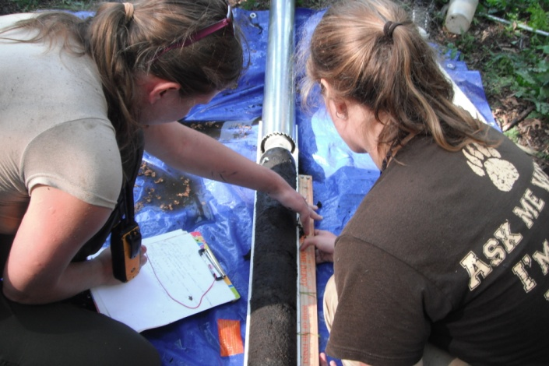
During the summer of 2011, the ponds were cored by a research team from Brown University (pictured on the left) to learn about how and why the species found in the pond plant communities had changed since industry had taken over the area.

The Miller Woods ponds are a valuable place for research because so much information about them has been accumulated over the years. This amount of available data is why many scientists choose to do research here. Also, the ponds contain many unique communities of plants and animals. The more we can learn about what caused past changes, the more we can protect the ponds from future changes.
What is a sediment core?

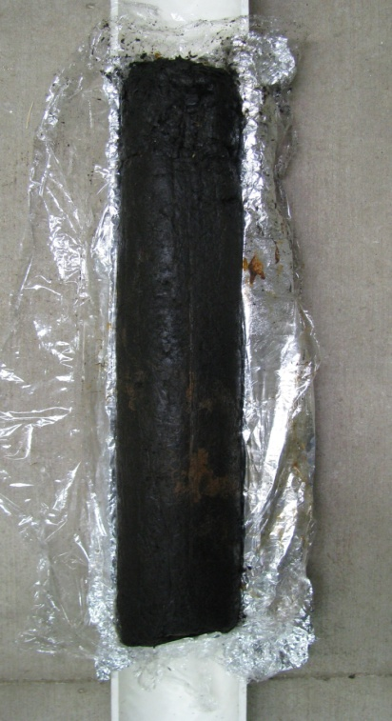
A sediment core is a tube of sediment collected from the bottom of an ocean, lake or pond. The sediment core can then be studied to reveal preserved evidence of the organisms that lived as the sediment was formed. The depth of the core is used to determine the age of the specimens found since younger fossils are usually found in layers above older fossils. (Figure A). Using the depth of fossils to determine which is older than others is called relative dating but it doesn’t give information about actual age of the fossils. In this activity we will assume that the sediment length increases 45.5 mm per year. Therefore, 1 cm of core length = 22 years of sedimentation.

← Top of Core

← Macrofossils found at higher levels are younger than those in deeper layers

← Macrofossils found deeper older than those found at higher levels since deeper layers settled first.

← Bottom of Core

Figure A: Sediment Core from Miller Woods

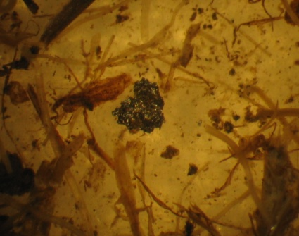
By identifying the macrofossils throughout the core, it is possible to tell which plants were present when each sediment layer was formed. A macrofossil is a preserved leaf, seed or other plant segment useful in identifying the plants growing in the area during that time period. We can also find evidence of human activities in cores, such as the metal particle in the image to the left.

Pre Lab Questions:

- How did the ponds form?
- Why are there fewer ponds today than when Henry Cowles began to research the plant communities of the Miller Woods?
- What is a sediment core?
- Which layer of sediment was formed first: one found 15 cm deep or one found 6 cm deep? Explain.
- Which sediment layer contains the older macrofossil: one found 17 cm deep or one found 12 cm deep? Explain.
- How many years are represented in 1 centimeter of sediment?
- If a sediment core is 4 centimeters long, how many years of sediment does it contain?

Part 2- Data Collection:

Name: _________________________________________________________Date:_______________Class:___________

Objective: In this activity, we will collect data from the most recent cores taken from the Miller Woods ponds. We will use an interactive web site that allows you to zoom in on the actual macrofossils found by researchers from Brown University.

Go to the Online Core Sample #2: http://coolhub.imsa.edu/web/core-project/core2
Complete the data table by checking off if the sample type was present at that depth.
Core Depths (cm) |  | Sample types
Actual | Model | Industrial particles | Proserpinaca palustris seed | Brasenia schreberi seed | Scirpus sp. seed | Cyperaceae trigonous seed
Bead Color |  | Black | Green | Yellow | Pink | Orange
2-4 | 1
6-8 | 2
10-12 | 3
14-16 | 4
18-20 | 5
22-24 | 6
26-28 | 7
30-32 | 8
34-36 | 9
38-40 | 10
Core Depths (cm) |  | Sample types
Actual | Model | Quercus sp. leaf | Eleocharis sp. seed | Ambrosia pollen | Polygonum hydropiperoides seed
Bead Color |  | Blue | Purple | Red | White
2-4 | 1
6-8 | 2
10-12 | 3
14-16 | 4
18-20 | 5
22-24 | 6
26-28 | 7
30-32 | 8
34-36 | 9
38-40 | 10
Name: _________________________________________________________Date:_______________Class:___________

Data Analysis Questions:

- How long ago did industrial particles begin to appear in the sediment? Show your work. (Hint: Remember that 1cm = 22 years).

- Where did these particles come from?

- What plant first appeared in the sediment around the same time?

- What is the possible link between the two occurrences?

- Based on this sediment core what two plants seem to have disappeared from the pond community?

- What could have caused these losses?

- Why do you think some macrofossils seem to disappear then reappear in the sediment core?

Part 3- Making a Model Core

Objective: In a hands-on session, your team will create a model sediment core using the data collected from the online portion as a guide. We are reminded that new layers of sediment form over the older layers allowing researchers to determine which macrofossil is older than another using relative dating. The formation of the core also reconstructs a history of the plant community of the pond for a better understanding of human impacts on plant succession.

Materials:

-Coring Pipe
-Colored Pencils
-Rulers
-Wax Paper
-Modeling Clay
-Plastic Beaker or Cup
-Plastic Butter Knife
-Mug

-Pony Beads

White 3
Green 5
Yellow 3
Pink 6
Orange 5
Red 5
Purple 7
Blue 4
Black 5

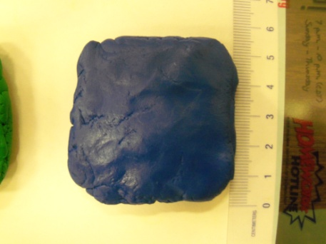
- Complete the Part 2 data table before going on! Then begin by placing a 5 cm x 5 cm layer of clay approximately ½ centimeter thick in the beaker to represent the first, or deepest, layer of sediment in the core. Use a cup or mug to help roll out the clay on wax paper. Keep the clay on wax paper while you work.
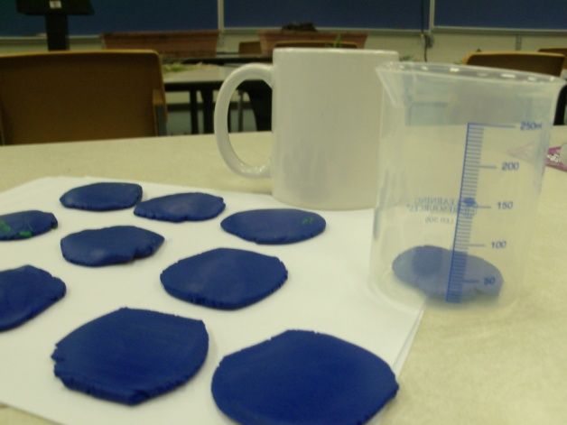
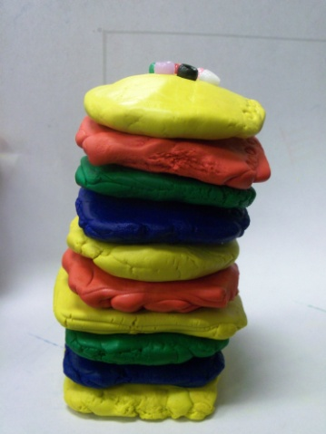
- Using the data table from the Part 2 as a guide, place one of each color bead that represents macrofossils found at that depth into the center of the clay.

- Repeat steps one and two layering the clay one on top of the next until you have built and stacked together all 10 layers.

- Take a core sample by pressing your coring pipe straight downwards into the middle of the sample and pull it out slowly.
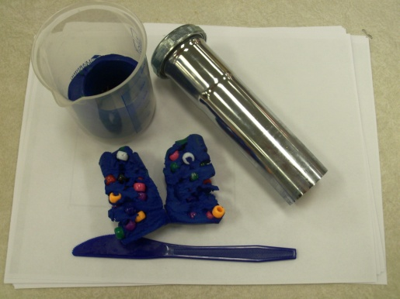

- Carefully remove the core from the pipe by gently pressing your core back out.

- Use the plastic butter knife to cut the core in half.
Name: _________________________________________________________Date:_______________Class:___________

Post Lab Questions:
- Measure and record the length of the core.

- How many years does it represent of sedimentation if 1 cm=22 years?

- Draw a picture of what you see in each layer and label the different bead colors found.

- How do you think that this is similar to the way scientists collect sediment cores from ocean and lake beds? How is it different?

- Predict what plants would be growing in the pond today in the sediment.

- Some of the plants found today were also found 50, 100, 150 and more years ago. Why do you think there is no evidence of them in the sediment?

