Teacher Resources - Sediment Core Modeling:
Activities inspired by a research project that uses historical plant data to understand the impact of 1900s settlement and industrialization on ponds in the Indiana Dunes Lakeshore area.

Objective:
- Students first learn about the formation of the Miller Woods ponds system of northwest Indiana. This information is then used to help students construct an understanding of the purpose of coring for macrofossils.
- Next, students use an interactive online sediment core example to collect data on species identifications of macrofossils found in an actual core taken from a Miller Woods pond and the depths in the core at which each was found.
- In a hands-on session, students create a model core using the data collected from the online portion as a guide. Students learn that new layers of sediment form over the older layers leading to the idea of relative dating. The formation of the core reconstructs a history of the plant community of the pond for a better understanding of human impacts on plant succession.
A higher level variation is provided for upper grade levels or accelerated classes. A data sheet is provided for reference.

Materials

-Modeling Clay
-Plastic Beaker or Cup
-Pony Beads in colors
-Plastic Butter Knife
-Rolling Pin or Coffee Mug
-Rulers

-Colored Pencils enough so that students can illustrate their layers
-1.5 inch x 6 inch Extension Tube Pipe or similar sized pipe*
* Pipe should have narrow end for cutting through clay / PVC not recommended.

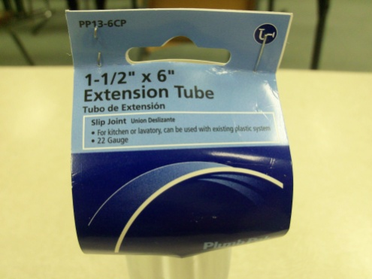
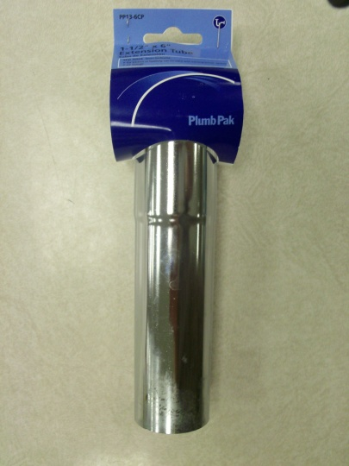
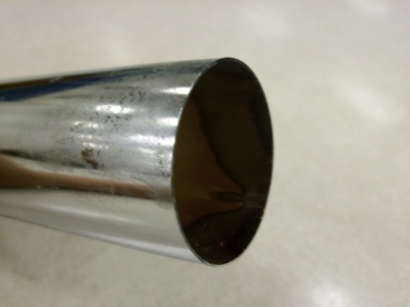

Plant Types Found in the Miller Woods ponds

Brasenia schreberi
Cyperaceae trigonous
Cephalanthus occidentalis
Eleocharis sp.
Nuphar advena
Polygonum hydropiperoides
Proserpinaca palustris
Quercus sp. (leaf fragments)
Scirpus sp.
Typha sp.
Ambrosia (pollen)

Set-up:
Part 1: A short pre-lab reading portion catches students up on background information important to the rest of the lesson. Following the reading is a series of pre-lab questions to assess student readiness for concepts addressed in the interactive online portion.
Time requirement: 15-20min

Part 2: Data collection is carried out online using an interactive website. This site allows students to zoom in on macrofossils found in an actual core during the summer of 2011 by researchers from Brown University. Accompanying questions assess understanding of vital concepts.
Web Address: http://coolhub.imsa.edu/web/core-project/core2

Time requirement: 20-30min

Part 3: Data collected in part 2 is put to use as students build a model of the core using clay and beads. 10 squares of clay, each 0.5cm thick, are layered in alternating colors while beads are added represent macrofossils that scientists collect from sediment layers. The core is extracted using a metal pipe and can be examined by cutting it in half to reveal the macrofossils within.
Time requirement: approx. 1hour

A higher level variation of the activity can include the use of one clay color instead of alternating color layers. This solid color is more representative of what an actual core would look like. Students can then slice the core into layers and analyze their findings as would be done in the real laboratory setting.
Time requirement: 1½ - 2 hours

Core #2 Data Sheet Key
Core Depths (cm) |  | Sample types
Actual | Model | Polygonum hydropoperoides | Proserpinaca palustris | Brasenia schreberi | Scirpus sp. | Cyperaceae trigonous
Bead Color |  | White | Green | Yellow | Pink | Orange
2-4 | 1 | √ | √ |  | √
6-8 | 2 | √ | √ |  | √
10-12 | 3 |  | √ |  | √
14-16 | 4 |  | √ |  | √
18-20 | 5 |  |  |  | √ | √
22-24 | 6 |  |  | √ |  | √
26-28 | 7 |  |  |  |  | √
30-32 | 8 |  | √ |  |  | √
34-36 | 9 |  |  | √
38-40 | 10 | √ |  | √ | √ | √
Core Depths (cm) |  | Sample types
Actual | Model | Ambrosia | Eleocharis sp. | Quercus | Industrial Particles
Bead Color |  | Red | Purple | Blue | Black
2-4 | 1 | √ | √ |  | √
6-8 | 2 | √ |  | √ | √
10-12 | 3 | √ |  | √ | √
14-16 | 4 | √ |  |  | √
18-20 | 5 | √ | √ |  | √
22-24 | 6 |  | √ | √
26-28 | 7 |  | √ | √
30-32 | 8 |  | √
34-36 | 9 |  | √
38-40 | 10 |  | √

Data Analysis Questions:

- How long ago did industrial particles begin to appear in the sediment? Show your work. (Hint: Remember that 1cm = 22 years).

Industrial particles are found as deep as 18cm in the core.
18 cm x 22 years per centimeter = 396 years ago

- Where did these particles come from?

The industrial Revolution brought steel mills to the area along with increased human settlement.

- What plant first appeared in the sediment around the same time?

Ambroshia also appears for the first time at a depth of 18cm.

- What is the possible link between the two occurrences?

Human settlement brings with it or causes an increase in growth of this species.

- Based on this sediment core what two plants seem to have disappeared from the pond community?

Brasenia schreberi was last found at a depth of 22cm and Cyperaceae trigonouswas last found at a depth of 18cm in the sediment core.

- What could have caused these losses?

Both species seem to disappear at about the same time as the growth in human settlement has lead to industrialization which leads to the possibility that this has caused their disappearance.

- Why do you think some macrofossils seem to disappear then reappear in the sediment core?

Some species are not able to form macrofossils as easily as others. Or conditions for their growth may not have been favorable for sometime but then returned to optimal conditions.

Post Lab Questions:

- Measure and record the length of the core.

Answers will vary

- How many years does it represent of sedimentation if 1 cm=22 years?

Answers will vary

- Draw a picture of what you see in each layer and label the different bead colors found.

Diagrams will vary

- How do you think that this is similar to the way scientists collect sediment cores from ocean or lake beds? How is it different?

Scientists collecting sediment cores from ocean or lake beds drive a tube into the ground then pull it out. The sample is then cut to reveal what fossils can be found within in much the same way though on a much larger scale.

- Predict what plants would be growing in the pond today in the sediment.

Polygonum hydropoperoides, Proserpinaca palustris, Scirpus sp., Ambroshia, and Eleocharis sp. were all found in the most shallow layer of the core and should be currently growing in the pond today.

- Some of the plants found today were also found 50, 100, 150 and more years ago. Why do you think there is no evidence of them in the sediment?

Not all species of plants are able to form fossils. Conditions must be right to form a fossil. Conditions for the tissues of each plant to be able to form a fossil is different. Most plants will decay instead.

