Employee’s Name:
Job Title:
Department:
Supervisor:
Performance Period:
Date of Evaluation:
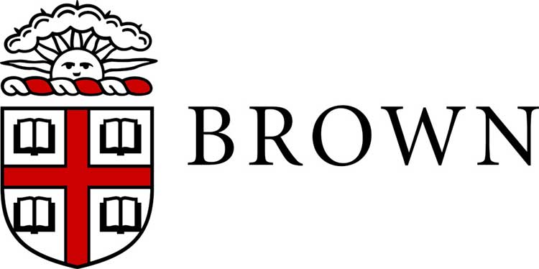
Annual Staff Performance Evaluation – Competency-Based

A best practice in preparing to complete this form is to review, and if necessary update, the job description to reconfirm the expectations for performance for the employee. As you complete this form, also consider goals established for this year.

- PERFORMANCE COMPETENCIES

Core Assessments: Check the rating that most closely represents your overall assessment of the employee’s performance. Comments in support of each rating are recommended. If performance in a competency requires improvement or is exceptional, comments are required.
Requires Improvement: | Demonstrates satisfactory performance in some areas; however does not perform or meet expectations consistently. Employee needs to acquire and/or develop necessary skills and build/sustain acceptable standard of performance. | Requires Improvement | Effective | Exceptional
Effective: | Consistently meets requirements of the position. At times employee may exceed expectations. Overall, employee makes solid, reliable and meaningful contributions to the department.
Exceptional: | Delivers exceptional results in performance against goals and core functions. Demonstrates innovation and initiative in all aspects of the position. Excellent work is widely recognized and positively and significantly impacts department/University operations.
- Job Knowledge: Possesses and continually updates requisite knowledge and understanding of assigned duties, responsibilities, policies, procedures and compliance requirements to perform the position. Demonstrates technical skills required for the position. Understands business needs and desired outcomes.
Comments and examples:
- Work Product: Demonstrates quality product including accuracy and thoroughness in work required for the position. Plans and completes acceptable quantity of work within deadlines. Works with diligence and identifies opportunities to streamline or improve processes.
Comments and examples:
- Customer Focus: Consistently exhibits professional demeanor with internal and external constituents and peers through verbal and written customer focused communication. This includes listening, understanding customer expectations/perspective and acknowledging and responding to concerns in a timely and helpful manner. Demonstrates commitment to exceptional service, timely problem resolution.
Comments and examples:
- Dependability/Accountability/Professionalism: Follows through on assignments. Takes ownership of work. Is reliable, professional and responsible. Adheres to procedures, practices, and work schedule. Work is completed in a timely manner and within established deadlines effectively using resources. Demonstrates commitment to professional development.
Comments and examples:
- Collaboration/Teamwork: Demonstrates cooperation and teamwork. Values and seeks input and expertise of others. Contributes to the team environment by working effectively with others on the team to accomplish work. Treats co-workers with respect, honesty and fairness. Resolves issues effectively and is viewed as a positive team member and/or colleague.
Comments and examples:
- Communication: Communicates effectively and respectfully verbally and in writing. Follows instructions and shares information appropriately. Engages in meaningful two-way conversations. Listens attentively and clarifies information when necessary.
Comments and examples:
- Commitment to/Demonstration of Inclusion & Welcoming Behavior in the Community: Creates a welcoming learning and working environment with productive and positive workplace relationships. Builds and supports a diverse and inclusive community by demonstrating respect in the workplace. Proactively identifies opportunities to increase awareness and hold self and others accountable for acting in a way which breaks down barriers between groups of difference and creates an inclusive climate that accepts and welcomes diversity.
Comments and examples:

Managerial Assessments: Check the rating that most closely represents your overall judgment of the employees’ performance as a supervisor. Comments in support of each rating are recommended. If performance in a competency requires improvement or is exceptional, comments are required.
Requires Improvement: | Demonstrates satisfactory performance in some areas; however does not perform or meet expectations consistently. Employee needs to acquire and/or develop necessary skills and build/sustain acceptable standard of performance. | Requires Improvement | Effective | Exceptional
Effective: | Consistently meets requirements of the position. At times employee may exceed expectations. Overall, employee makes solid, reliable and meaningful contributions to the department.
Exceptional: | Delivers exceptional results in performance against goals and core functions. Demonstrates innovation and initiative in all aspects of the position. Excellent work is widely recognized and positively and significantly impacts department/University operations.
- Management: Establishes performance expectations for staff. Provides timely, effective and meaningful feedback that motivates staff members to improve their performance. Builds and supports a high performing team. Assists employees in eliminating barriers to performance and provides encouragement for skill development. Delegates responsibility appropriately. Recognizes and rewards achievement.
Comments and examples:
- Leadership: Establishes clear vision for staff and motivates employees to achieve their best performance. Engages and motivates staff, coaching for peak performance. Promotes a welcoming, inclusive and supportive work environment and fosters continuous improvement. Makes outreach efforts and uses resources to create a diverse workforce. Leads and manages change. Builds and manages relationships across the department and University.
Comments and examples:

- ACHIEVEMENT OF GOALS
Identify the employee’s major achievements and progress toward meeting established goals.

- OVERALL PERFORMANCE RATING AND SUMMARY COMMENTS

Provide an overall performance rating based on the ratings assigned to core, and if appropriate managerial, competencies in this evaluation.
Requires Improvement □ Effective□ Exceptional □
Summarize the employee’s performance for this period paying particular attention to performance strengths and weaknesses and note areas and opportunities for professional development for the upcoming year. Clearly address performance that may require improvement or may be especially strong or exceptional.

- EMPLOYEE COMMENTS (Optional)
The employee may comment on the performance review in the space provided below.

Employee’s Signature: | Date:
Supervisor’s Signature: | Date:
Next Level Supervisor’s Signature

