Employee’s Name:
Job Title:
Department:
Supervisor:
Performance Period:
Date of Evaluation:
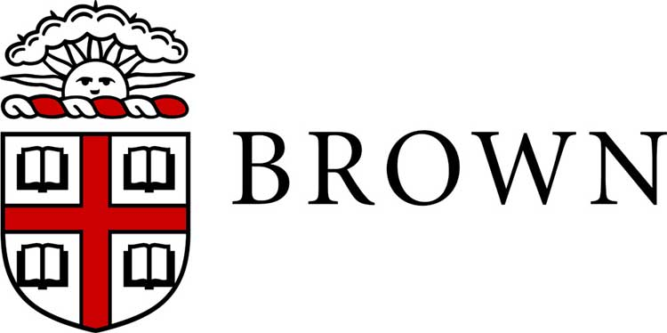

Annual Staff Performance Evaluation – Narrative
A best practice in preparing to complete this form is to review, and if necessary update, the job description to reconfirm the expectations for performance for the employee.
In completing this form include an assessment of the employee’s demonstration of Brown core competencies including Job Knowledge, Work Product, Customer Focus, Dependability/Accountability/Professionalism, Collaboration/Teamwork, Communication, Commitment to/Demonstration of Inclusion & Welcoming of Diversity; and for staff who manage others, Management and Leadership. Full definitions of these competencies can be found in the Performance Development Toolkit.

PERFORMANCE ASSESSMENT (Check one box below to rate overall performance for this period)

Requires Improvement: | Demonstrates satisfactory performance in some areas; however does not perform or meet expectations consistently. Employee needs to acquire and/or develop necessary skills and build/sustain acceptable standard of performance.
Effective: | Consistently meets requirements of the position. At times employee may exceed expectations. Overall, employee makes solid, reliable and meaningful contributions to the department.
Exceptional: | Delivers exceptional results in performance against goals and core functions. Demonstrates innovation and initiative in all aspects of the position. Excellent work is widely recognized and positively and significantly impacts department/University operations.

- Evaluate and discuss the employee’s overall job performance. Base your evaluation on the position requirements, achievement of the goals established during the past year, and your assessment of the employee’s accomplishments. Give specific examples to clearly support your assessment.

- Provide specific examples of exceptional performance that should be particularly noted.

- Provide specific examples of performance needing more attention or improvement.

- State and discuss the expectations and goals for the upcoming review period. Give examples of how these goals can be met including professional development opportunities.

EMPLOYEE COMMENTS (Optional)
The employee may comment on the performance review in the space provided below.

Employee’s Signature: | Date:
Supervisor’s Signature: | Date:
Next Level Supervisor’s Signature | Date:

