Employee’s Name:
Job Title:
Department:
Supervisor:
Probation Period Start:
Date of Evaluation:
New Probation End:
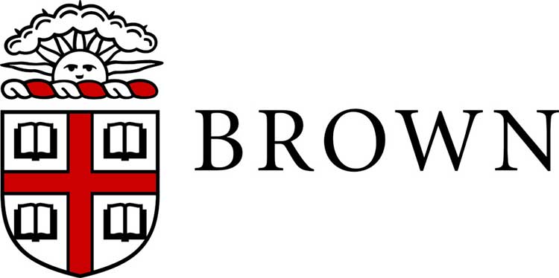
Probation Period Evaluation

Please indicate whether the staff member has been effective in demonstrating the competencies listed below based upon their time in the position. In addition, please note your recommended action with respect to the staff member’s employment with the University. Comments are required only for recommendations to Extend Probationary Period or Terminate Employment. Please contact your HR Generalist with any questions.

- PERFORMANCE COMPETENCIES

Core Assessments: Check the rating that most closely represents your overall assessment of the employee’s performance during their probation period. Comments in support of each rating are recommended.
Requires Improvement: | Demonstrates satisfactory performance in some areas; however does not perform or meet expectations consistently. Employee needs to acquire and/or develop necessary skills and build/sustain acceptable standard of performance. | Requires Improvement | Effective
Effective: | Consistently meets requirements of the position. At times employee may exceed expectations. Overall, employee makes solid, reliable and meaningful contributions to the department.
- Job Knowledge: Possesses and continually updates requisite knowledge and understanding of assigned duties, responsibilities, policies, procedures and compliance requirements to perform the position. Demonstrates technical skills required for the position. Understands business needs and desired outcomes.
Comments and examples:
- Work Product: Demonstrates quality product including accuracy and thoroughness in work required for the position. Plans and completes acceptable quantity of work within deadlines. Works with diligence and identifies opportunities to streamline or improve processes.
Comments and examples:
- Customer Focus: Consistently exhibits professional demeanor with internal and external constituents and peers through verbal and written customer focused communication. This includes listening, understanding customer expectations/perspective and acknowledging and responding to concerns in a timely and helpful manner. Demonstrates commitment to exceptional service, timely problem resolution.
Comments and examples:
- Dependability/Accountability/Professionalism: Follows through on assignments. Takes ownership of work. Is reliable, professional and responsible. Adheres to procedures, practices, and work schedule. Work is completed in a timely manner and within established deadlines effectively using resources. Demonstrates commitment to professional development.
Comments and examples:
- Collaboration/Teamwork: Demonstrates cooperation and teamwork. Values and seeks input and expertise of others. Contributes to the team environment by working effectively with others on the team to accomplish work. Treats co-workers with respect, honesty and fairness. Resolves issues effectively and is viewed as a positive team member and/or colleague.
Comments and examples:
- Communication: Communicates effectively and respectfully verbally and in writing. Follows instructions and shares information appropriately. Engages in meaningful two-way conversations. Listens attentively and clarifies information when necessary.
Comments and examples:
- Commitment to/Demonstration of Inclusion & Welcoming Behavior in the Community: Creates a welcoming learning and working environment with productive and positive workplace relationships. Builds and supports a diverse and inclusive community by demonstrating respect in the workplace. Proactively identifies opportunities to increase awareness and hold self and others accountable for acting in a way which breaks down barriers between groups of difference and creates an inclusive climate that accepts and welcomes diversity.
Comments and examples:

Managerial Assessments: Check the rating that most closely represents your overall judgment of the employees’ performance as a supervisor. Comments in support of each rating are recommended.
Requires Improvement: | Demonstrates satisfactory performance in some areas; however does not perform or meet expectations consistently. Employee needs to acquire and/or develop necessary skills and build/sustain acceptable standard of performance. | Requires Improvement | Effective
Effective: | Consistently meets requirements of the position. At times employee may exceed expectations. Overall, employee makes solid, reliable and meaningful contributions to the department.
- Management: Establishes performance expectations for staff. Provides timely, effective and meaningful feedback that motivates staff members to improve their performance. Builds and supports a high performing team. Assists employees in eliminating barriers to performance and provides encouragement for skill development. Delegates responsibility appropriately. Recognizes and rewards achievement.
Comments and examples:
- Leadership: Establishes clear vision for staff and motivates employees to achieve their best performance. Engages and motivates staff, coaching for peak performance. Promotes a welcoming, inclusive and supportive work environment and fosters continuous improvement. Makes outreach efforts and uses resources to create a diverse workforce. Leads and manages change. Builds and manages relationships across the department and University.
Comments and examples:

- MANAGER RECOMMENDED ACTION

Continue employment Extend Probation (enter new date above) Terminate Employment

- EMPLOYEE COMMENTS (Optional)
The employee may comment on the performance review in the space provided below.

Employee’s Signature: | Date:
Supervisor’s Signature: | Date:

