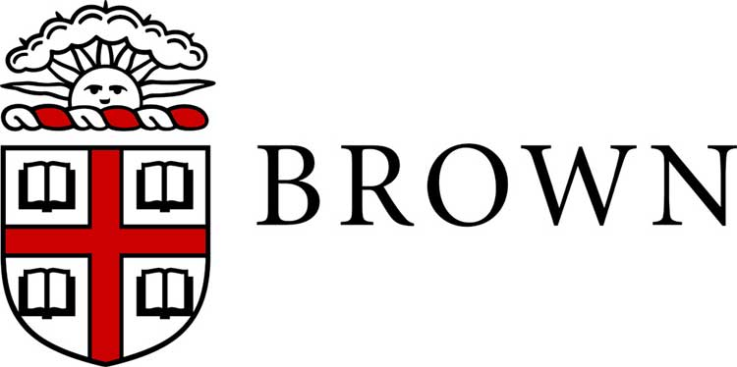
Employee’s Name:
Job Title:
Department:
Supervisor:
Planning Period:
Date Prepared or Reviewed:

Professional Development and Goal Planning

A best practice in planning for the coming year is to establish employee work goals and professional development activities. Performance goals set the direction for work in the coming year. Professional development may enhance the employee’s competency or skills in the current position and also prepare the employee for opportunities beyond this role.

Revisit this form quarterly to assess progress or to make adjustments as required based on changing departmental needs or priorities.

- PROFESSIONAL DEVELOPMENT

- Training Programs: Identify job-specific training programs at Brown or off-campus. This may include on-campus offerings, professional conferences, certification programs helpful to the performance of the employee’s current position including their role as a manager of staff, if appropriate.

- Work Projects or Tasks: Identify an opportunity for the employee to develop or enhance knowledge or skills to meet an anticipated need in the current role/department, or for the future. This may include preparing a written Development Plan outlining clear, measurable performance standards for the employee. More information about preparing a written Development Plan is available on the UHR website.

- PERFORMANCE GOALS

Use the SMART goal format to document work goals for the coming period. Goals should be linked directly to your department’s mission and Brown’s strategic plan, diversity and inclusion initiatives or other work or projects. For those who supervise others, consider a managerial goal as well as individual work goals. SMART goals are:

- Specific: well defined, clear and unambiguous
- Measurable: define specific criteria for measuring progress toward accomplishing each established goal
- Achievable: require staff members to stretch but are not impossible to achieve
- Relevant: the goal is related to the department’s mission and/or a specific project or program
- Timely: the time frame is clearly defined or progress toward achievement is tracked at regular intervals

- Goal and Timeline for Completion

- Goal and Timeline for Completion

Employee’s Signature: | Date:
Supervisor’s Signature (Optional): | Date:

