

**D’Abate Community School**

**Supplemental Report One**

Rhode Island 21st Century Community Learning Center (21st CCLC) Initiative

2015-16 ANNUAL PROGRESS REPORT

Prepared by STATCOM, an initiative of the Swearer Center for Public Service

August 12, 2016

Su H. Chu, M.S.

PhD Candidate

Department of Epidemiology, Brown University

Yi Zhao, M.S.

PhD Candidate

Department of Biostatistics, Brown University

Mengna Huang, M.P.H.

PhD Candidate

Department of Epidemiology, Brown University

***Hypothesis 1a: 95% of incoming kindergarten students who participated in D'Abate Community School (DCS) summer camp demonstrate increased kindergarten readiness based on summer survey data.***

METHODS

DCS incoming kindergarten students were administered a survey in the fall of 2015 to assess their readiness in transitioning from attending kindergarten to elementary school. The respondents of the survey included both those who participated in the DCS summer camp (hereinafter called “campers”), and those who did not participate (hereinafter called “non-campers”). These incoming kindergarten students were asked various questions in the following groupings:

* Write out their first and last names (rated 3 for all letters, 2 for some letters, 1 for few letters, and 0 for no letters correct)
* Write out the numbers 1 to 10 (rated in the number of correct numbers)
* Recognize letters in both upper and lower cases (rated in the number of correct letters)
* Draw three shapes and a person (rated 1 for each correct shape and body part)
* Additionally, their teachers were asked to evaluate the students in different aspects of social and classroom engagement behaviors in nine questions with the same frequency rating scale (5 for always, 4 for often, 3 for sometimes, 2 for rarely, and 1 for never). The behaviors included following directions, participation, willingness to help others, socializing with classmates, focusing, expressing thoughts and feelings clearly, and excitement about learning, etc. Higher scores corresponded to more positive evaluation.

To assess whether 95% of the campers demonstrated increased kindergarten readiness, we would need data from 20 campers from both before and after the summer camp to assess the differences. Since we only have limited camper data at the moment, this hypothesis was not tested. We were only able to perform some descriptive analyses of the survey data from fall 2015. All scores were scaled to 0 – 1 for each of the question groups described above.

RESULTS

A total of 76 students participated in the survey, and 9 of them were DCS summer campers. These 9 campers scored an average of 54% in correct spelling of their names, an average of 70% in correct writing out numbers 1 – 10, an average of 70% in correct identification of letters, and an average of 72% correctness of drawing. The teachers scored the campers an average of 65% in social and classroom engagement behaviors.

***Hypothesis 1b: Kindergarten students who participated in DCS summer camp maintain “readiness” and “engagement” through the academic year as compared to kindergarten students who did not participate in DCS summer camp.***

METHODS

In addition to the survey described in hypothesis 1a, the same group of students and their teachers were administered the same survey again at the end of the academic year in May 2016. Similar as the fall 2015 survey, all scores were scaled to 0 – 1 for the each of the question groups described above.

To assess whether campers maintained their readiness and engagement through the academic year as compared to non-campers, the average increases in the above five measurements from fall 2015 to May 2016 were computed and compared between the campers and the non-campers. Analysis of variance of linear models were performed to test for a significant difference in the increases in these five scores, controlling for the students’ teacher/classroom.

Please note that one of the teachers did not answer the questions regarding social and classroom behaviors at this survey, so this part of data at this time point (May 2016) were entirely missing for 26 students, who were all non-campers.

RESULTS

*Preliminary Analyses*

A total of 76 students participated in the fall 2015 survey, and 9 of them were DCS summer campers. In the May 2016 survey data were missing for 6 non-campers and 1 camper, resulting in a total of 69 students participating, with 8 being DCS summer campers.

Scores on the five measurements from both the fall 2015 survey and the May 2016 survey were summarized (Figure 1a), with data from fall 2015 on the left side of each panel, and data from May 2016 on the right side of each panel. Again the five measurements included: 1) score in correct spelling of students’ names; 2) score in correct writing out numbers 1 – 10; 3) score in correct identification of letters; 4) score in correctness of drawing; and 5) score in rating of social and classroom engagement behaviors from teachers. The plots revealed improvement in almost all five measurements from fall 2015 to May 2016, for campers, non-campers, or the overall student body, reflected in the increases in the mean values of each score.

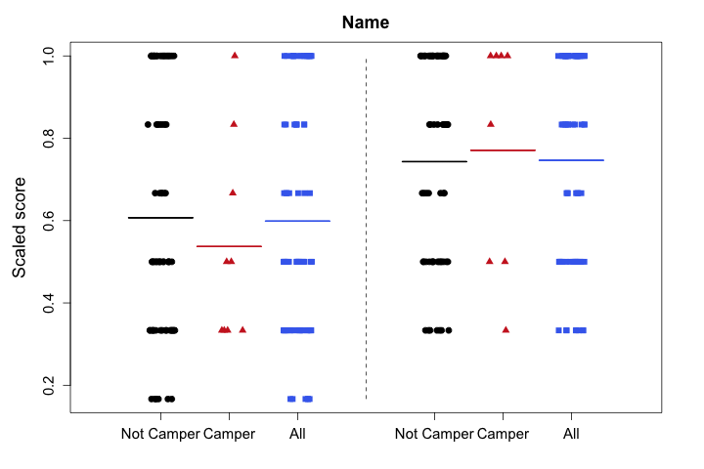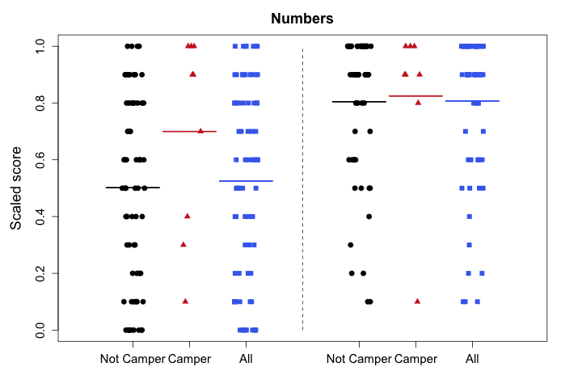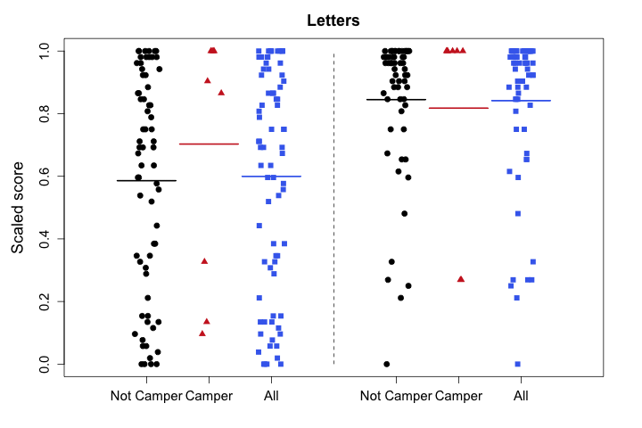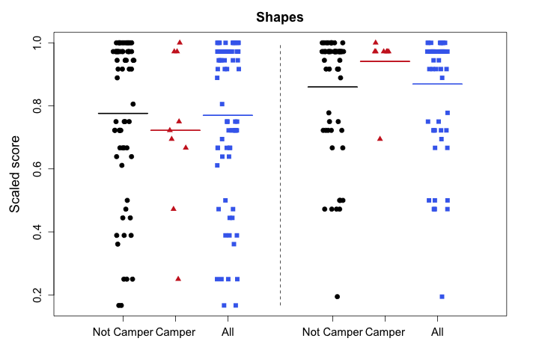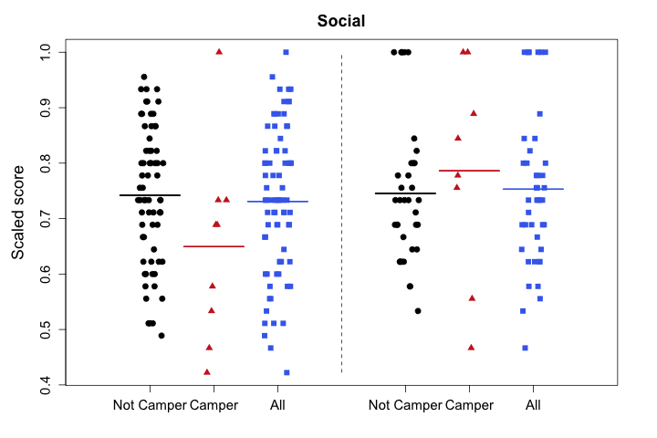

Figure 1a. Jitterplot of kindergarten readiness survey score distribution of all incoming students to DCS in fall 2015 (left side in each panel) and May 2016 (right side in each panel). Scores were summarized for non-campers (black circles), campers (red triangles), and all students (blue squares). In each panel, solid lines indicate the mean value or average of scores from the corresponding group of students.

*Kindergarten students who participated in DCS summer camp maintained higher performance in certain aspects of “readiness” and “engagement” through the academic year as compared to kindergarten students who did not participate in DCS summer camp.*

Among the five measurements of readiness and engagement, campers demonstrated significantly higher increase in scores of correct spelling names, correct drawing shapes, and teacher-rated social and classroom engagement behaviors, as compared to non-campers (Figure 1b). The increase in scores of correct numbers and correct letters were also apparently higher for campers, but they were not significantly different from 0. It is noteworthy that data were available for only 8 campers in these comparisons, so there might not be enough power to detect significant differences in comparing scores of correct numbers and correct letters. Overall we believe that the data showed a beneficial impact of the DCS summer camp on readiness and engagement of kindergarten students as measured by the survey.

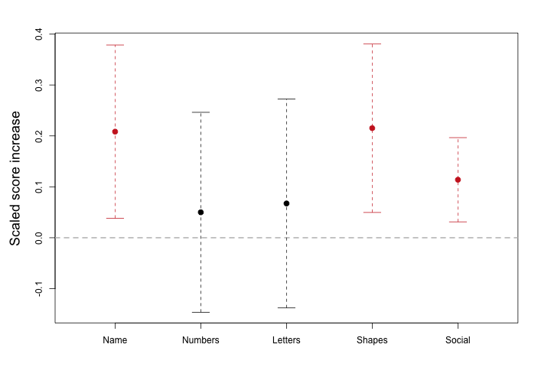

Figure 1b. Interval plots of differences in score increase comparing campers to non-campers for five measurements: 1) score in correct spelling of students’ names; 2) score in correct writing out numbers 1 – 10; 3) score in correct identification of letters; 4) score in correctness of drawing; and 5) score in rating of social and classroom engagement behaviors from teachers. The dots represent the point estimates, and the brackets represent 95% confidence intervals. Compared to non-campers, campers had significantly higher score increase in the correct spelling of names, correct drawing of shapes, and teacher-rated social and classroom engagement behaviors, but the score increase in correct numbers and letters was not significantly different from 0.

***Hypothesis 2a: 90% of 4th and 5th graders who participated in DCS report social-emotional growth as measured by the internal survey.***

We are unable to directly assess this hypothesis because data on social-emotional growth were only measured at one time-point using the internal SAYO-based survey in the 2015-2016 4th and 5th grade cohorts. We are unable to make general comparisons with the SAYO results either for the following reasons.

* The SAYO results from 2014 were worded differently and the response scales used were different from those used in the internal survey; the SAYO used degrees of agreement (‘yes’, ‘mostly yes’, ‘mostly no’, ‘no’) while the internal survey used degrees of frequency (‘always’, ‘most of the time’, ‘sometimes’, ‘never’).
* The SAYO surveys were conducted on different students during a different year from the internal survey on the DCS 4th and 5th graders.
* The best that we can offer here is an exploratory data analysis of the scores that are available internally. However, no statement regarding growth can be made with these data. Even qualitative comparisons should be made with caution due to lack of direct comparability between the questions and the groups. (Supplementary Figure 1).

***Hypothesis 2b*: *During the 2015-16 school year, at least 90% of 4th and 5th grade students participating in DCS will report that the DCS afterschool program helps them: try harder in school, do better in school, feel good about themselves, find out what they’re good at doing and what they like to do, and make new friends.***

METHODS:

DCS participants in the 4th and 5th grade during the 2015-16 school year were administered a survey in spring 2016 to assess their feelings regarding the DCS program using an internal survey. The 4th/5th grade DCS participants were asked regarding the frequency with which:

* they felt happy to attend the afterschool program (happy I go)
* afterschool club (ASC) te)chers made learning fun (learning fun)
* ASC teachers gave them things to do that made them think (think hard)
* ASC participation
  + helped them do better in school (do better)
  + made them feel good about themselves (feel good)
  + helped them find out what they are good at and what they like to do (good at/like)
  + helped them make new friends (make new friends)
* they talked about ASCs at home (talk at home)

All responses were scored on a Likert scale as follows: Never (1), Sometimes (2), Most of the Time (3), Always (4). Higher scores corresponded to more positive responses.

To assess whether 90% of students had positive responses regarding whether the DCS ASCs were helping them build social-emotional skills in the measures reported above, one-sample one-sided Z-tests of proportion were conducted.

RESULTS

*90% of DCS 4th/5th graders reported that ASCs made learning fun, and made them happy to go to school and feel good about themselves*

Across the measures of the social-emotional (SE) impact of the DCS ASCs, there was insufficient evidence to reject the hypotheses that 90% of 4th and 5th grade students were happy to attend the DCS ASCs (p=0.990), felt that the DCS program made learning fun (p=0.817), and made them feel good about themselves (p=0.666). In general, the percentages of students who felt positively about the DCS ASCs across all the measures ranged from 61.2% to 100% -- indeed, 100% of all DCS participants felt happy to attend the DCS ASC programs. While the DCS program did not meet the 90% benchmarks for the other measures of think hard, do better, try harder, good at/like, make new friends, and talk at home, the estimated percentages of students who reported positive responses regarding the DCS ASC programs were in general quite high.

|  |  |  |  |
| --- | --- | --- | --- |
| SE Measure | Estimated Proportion | 95% CI | P-value |
| Happy I Go | 1.000 | (0.916, 1.000) | 0.990 |
| Learning Fun | 0.939 | (0.855, 1.000) | 0.817 |
| Think Hard | 0.612 | (0.528, 0.696) | 9.45E-12 |
| Do Better | 0.816 | (0.732, 0.900) | 0.025 |
| Try Harder | 0.816 | (0.732, 0.900) | 0.025 |
| Feel Good | 0.918 | (0.834, 1.000) | 0.666 |
| Good At/Like | 0.776 | (0.692, 0.860) | 0.002 |
| Make New Friends | 0.816 | (0.732, 0.900) | 0.025 |
| Talk at Home | 0.776 | (0.692, 0.860) | 0.002 |

***Hypothesis 3: 90% of all DCS participants demonstrate social-emotional growth across each applicable measure in the social-emotional growth survey.***

METHODS  
DCS participants in grades K-5 (N=182) were administered surveys to assess social-emotional (SE) growth across a range of measures. These measures of SE growth were obtained via pre- and post-tests which captured self-reported degrees of agreement with respect to whether DCS participants: 1) turned in homework on time (homework; not measured in Kindegarteners); 2) put their best effort into schoolwork (effort); 3) worked hard when faced with a difficult question (work); 4) knew an adult they could talk to when upset (trust); 5) enjoyed coming to school (enjoy); 6) liked making new friends (friends); and 7) knew the subjects in which they performed best (subjects). All questions were scored on a Likert scale as follows: 1 (No), 2 (Mostly No), 3 (Mostly Yes), 4 (Yes). Higher scores corresponded with more positive responses.

Chi-square tests of proportions with Yates continuity corrections were conducted to assess whether 1) 90% DCS participants demonstrated SE growth in across the seven measures and 2) 90% of DCS participants were able to maintain *or* increase their SE scores throughout the year. To assess whether DCS participants demonstrated evidence of significant SE growth, the difference between pre- and post-test scores (i.e. change-scores) were calculated. Analysis of variance of linear models were performed to test for a significant increase in SE scores, controlling for the effect of grade in school categorized as K/1, 2/3, and 4/5.

RESULTS

*Preliminary Analyses:*

Exploratory data analyses of DCS participant scores in the SEG survey revealed highly positive student responses with respect to self-reported agreement in all SEG measures, even at baseline. Notably, the average social-emotional scores increased in measures of effort, trust, and friends, were largely maintained for work and subjects, and slightly decreased in homework and enjoyment (Figure 3a).

The distributions of change scores across the SE measures across all grades showed that the majority of DCS participants maintained or increased their SE scores across all seven measures. Across the SE variables, the percentages of students who maintained or increased their scores ranged from 79.2% to 89.9% (Figure 3b).

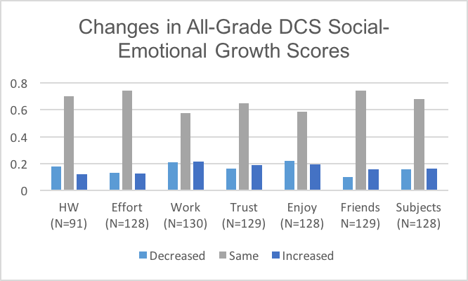

Figure 3b. Barplot of SE change-score distributions across all DCS participants for the 2015-2016 academic school year.

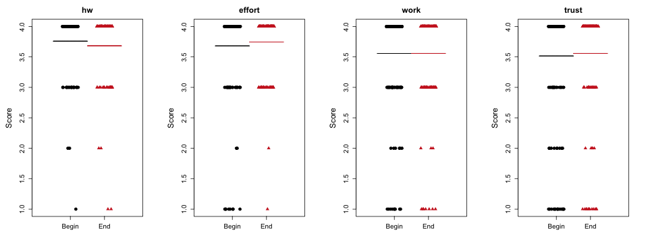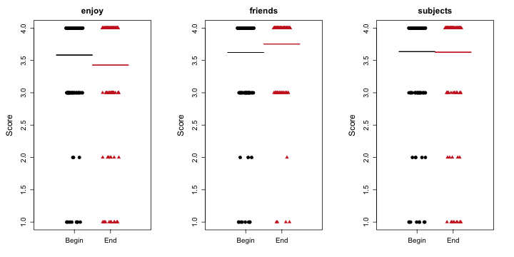

Figure 3a. Jitterplot of SE score distributions of all DCS participants at the beginning (black circles) and end (red dots) of the 2015-2016 academic school year. In each panel, solid lines indicate the overall mean across all students for the relevant SE measures at the beginning (black) and end (red) of the school year.

*90% of DCS participants maintained or increased SE scores in SE measures of effort and fostering new friendships*

Among the measures of SE, there was insufficient evidence to reject the hypothesis that 90% of DCS participants *maintained or increased* their SE abilities throughout the school year in 1) putting their best effort into schoolwork and 2) their enjoyment of making new friends. However, when assessing whether 90% of DCS participants demonstrated strict increases in SE measures, there was significant evidence in favor of the true proportion of students who demonstrated SE growth being *less* than 90% across all measures.

|  |  |  |  |  |  |  |  |
| --- | --- | --- | --- | --- | --- | --- | --- |
| **Table 3a. One-Sided Chi-Square Test of Proportions for DCS Participant SE Growth.** | | | | | | | |
| **SE Growth Category** | **HW (N=91)** | **Effort (N=128)** | **Work (N=130)** | **Trust (N=129)** | **Enjoy (N=128)** | **Friends N=129)** | **Subjects (N=128)** |
| Maintained or Increased | 0.0127 | 0.138 | 3.96E-05 | 0.0129 | 7.42E-06 | 0.5 | 0.0242 |
| Increased | 6.35E-134 | 3.24E-186 | 6.67E-148 | 1.73E-159 | 3.26E-154 | 1.64E-173 | 4.63E-168 |

*Grade-specific patterns of significant growth were identified in SE measures of effort and friends; however, DCS participants did not demonstrate significant SE growth overall*

Overall, DCS participants did not demonstrate evidence of significant increases in their SE scores comparing between the beginning and the end of the year across all SE growth categories (Figure 3c).

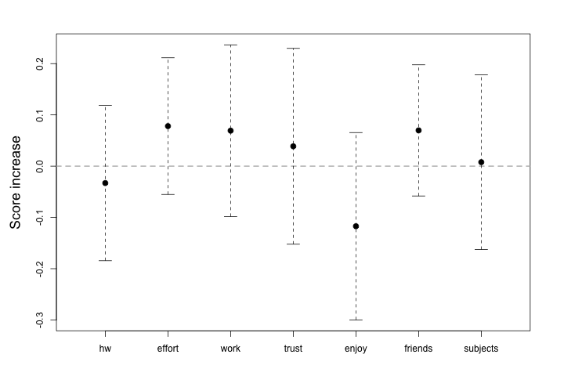

Figure 3c. Interval Plots of SE Growth Categories Across All DCS Participants. There was insufficient evidence to reject the hypothesis that increases in scores across all the SE categories were significantly different from 0.

However, in a stratified analysis of the SE categories by grade, we identified grade-specific significant growth in two SE categories: effort (K/1) and friends (4/5) (Figure 3d).

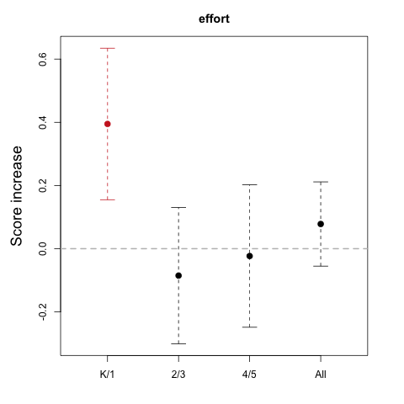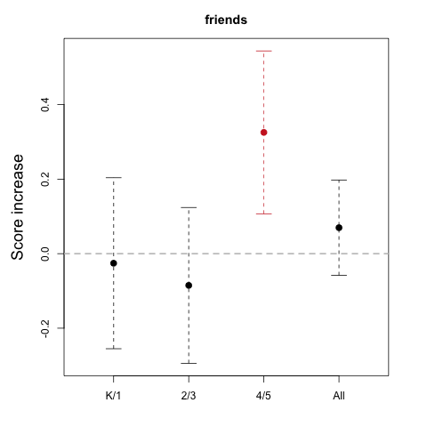

In putting in their best effort in school, K/1 DCS students demonstrated a significant mean increase of 0.395 points (p=0.001) in SE score from the beginning to the end of the academic year. In enjoying making new friends, 4th/5th grade DCS students demonstrated a significant mean increase of 0.326 points (p=0.003) in SE score from the beginning to the end of the academic year.

*Although we were not able to identify significant score increases in the overall population of the DCS participants, this may be in part due to the majority of DCS participants reporting high baseline SE scores – there was, overall, very little room for improvement (see Figs 3a and 3b). It is also possible that the DCS participants who were surveyed for these analyses were biased as we were unable to control for age, gender, race, and previous DCS participation, all of which could impact the distribution of change scores.

**Supplemental Figures and Tables.**

**Figure S1. Barplots of 4th/5th grade DCS participant responses to the internal survey measuring the impact of DCS ASC impact on social-emotional performance.**

R/160806/h2.barplots.pdf