CLASSROOM AUDIO/VISUAL GUIDELINES

GENERAL

SUMMARY

Guidelines: Installed classroom AV design is inherently tied to the specific space in question. Factors such as ambient light control, sound reflectivity, size and shape all play a role in determining appropriate display tools.

Designs should reflect the industry standard DM (digital media) signal transmission.

Designs should recognize the need to refresh AV equipment and cabling on average every five years.

Projects that result in spaces that will be scheduled by the Registrar are required to add Crestron DM room control system with LCD touch panel interface as well as programming to add spaces(s) to the CIS RoomView server.

SUBMITTALS

Product Data: Submit manufacturer's product data and installation instructions for each material and product used.

Shop Drawings: Submit shop drawings indicating material characteristics, details of construction, connections, and relationship with adjacent construction.

Warranty: Submit manufacturer’s standard warranty. We require 2 years parts & labor extended warranty on all installations. Include labor and materials to repair or replace defective materials. Warranties must be submitted as a project deliverable.

Maintenance Data: Submit manufacturer’s maintenance data, including maintenance schedule.

Extra Stock: Submit extra stock equal to 2 percent of total used.

QUALITY ASSURANCE

Comply with governing codes and regulations. Provide products of acceptable manufacturers which have been in satisfactory use in similar service for three years. Use experienced installers. Deliver, handle, and store materials in accordance with manufacturer's instructions.

Electrical Components, Devices, and Accessories: Listed and labeled as defined in NFPA 780, "Definitions" Article.

PRODUCTS

ROOM SPECIFICATIONS

Smaller spaces (<12 seats) are typically outfitted with:

Large format digital flat panel display (LED commercial/professional models)

Direct input HDMI

Flat panel displays have built-in speakers for audio playback.

Hard room network taps specified for patron access to the web-based video.

Ethernet connection is also needed for the RoomView Express room-control/monitor software.

HDMI wall plate digital media transmitter

Crestron Digital presentation system DMPS-4K-250-C with built in Airmedia

Crestron LCD touch panel TSW-760. Crestron button panel may be an appropriate alternate control device vs. LCD touch panel depending on complexity of install.

Install requires minimum (2) data taps dedicated to room control/operation.

AirMedia wireless presentation system requires a dedicated hard-wired Ethernet connection on appropriate VLAN (172.xx.xx.xx) established by Network Ops.
      - Install of new Middle Atlantic RLNK-915R

Medium spaces (15-25) vary greatly in approach. Typically a projector/screen combination is specified, but depending on pedagogy and room layout:

Dual flat panels (LED commercial/professional models).

Eiki LC-WUL100A (LCD) will be replaced with Panasonic PT-RZ570WU (laser). Because of their brightness (5000 lumens) these units are appropriate for most spaces (appropriate lenses will be spec-ed for applicable throw distances).

Installed projection screen, recessed/powered/tensioned where appropriate (DaLite).

Depending on room size, installed room speakers may be required for audio playback. (JBL Control Series or equivalent Crestron Saros Series; sized/quantity to space; ceiling-voice; wall-program)

Equipment rack can either be free standing or contained within room podium/credenza.

Digital room system (Crestron DMPS-4K-250/350)

HDMI wall plate transmitter

LCD touch panel (Crestron TSW-760 or TSW-1060 depending on complexity of installation).

The Crestron room control system in the rack requires network connectivity for remote access

Install requires minimum 2 data taps dedicated to room control/operation.

AirMedia wireless presentation system requires a dedicated hard-wired Ethernet connection on appropriate VLAN (172.xx.xx.xx) established by Network Ops.

Consider addition of installed webcam for use with Zoom web conferencing. MS to specify make/model at time of system design.

Highly recommend accessible audio (XLR) and video (HDMI) record outs for Media Production Group recording/streaming functionality.
      - Install of new Middle Atlantic RLNK-915R

Large spaces (+50) dependent on room configuration and materials to be displayed:

Multiple projectors are positioned so as to enable projection and simultaneous use of whiteboards. This requires projectors capable of creating viewable images in rooms lit for note-taking. Eiki LC-WUL100A (LCD) will be replaced with Panasonic PT-RZ570WU (laser). Because of their brightness (5000 lumens) these units are appropriate for most spaces (appropriate lenses will be spec-ed for applicable throw distances). In large venues that double as event spaces (very large screens, very long throw distances, film screenings) Panasonic PT-RZ12KU units are recommended (12,000 lumens).

Installed motorized projection screen(s), recessed/powered/tensioned where appropriate (DaLite).

Audio reinforcement is required in larger spaces, especially spaces that are dual-purposed for classroom and event activities. (JBL speakers , Audio-Technica wireless lavalier mics, subminiature condenser omnidirectional mic head and wireless handheld mics for each channel, powered antennas system, Yamaha soundboards, BSS digital audio processors, Crown amplifiers). Minimum (2) channels of wireless audio – (4-6) is optimal; up to (8) hard-wired audio mic inputs for panel discussions. Loudspeaker size, location and quantity are space-specific. (ListenTech assistive listening transmitters/receivers per ADA requirements for room size)

Teaching podium outfitted with a condenser gooseneck microphone (Audio-Technica). Consider installed computer with dedicated monitor (Dell small form tower + Planar monitor on articulating arm). Planar touch monitor can be configured to double as monitor for installed computer. Laptop connections HDMI, power, and Ethernet.

Digital soundboard is required to manage these audio signals. (Yamaha) Crestron programming to accommodate need for ‘live’ mode (mic mixing) and ‘auto’ mode - basic presentations with podium mic and 2-4 wireless channels. (Live mode/Auto mode in admin page. Along with pre-fade and post-fade selection for MPG record out.)

Require region-free BluRay/DVD (in booth) so visiting faculty/speakers from international locations can be accommodated (Sony).

Spaces of this size may be considered for lecture capture installation. This requires a Seneca HD (current campus standard) appliance, network connectivity and input feeds from teaching podium, HDMI, audio and as an option, installed room camera(s). Panopto lecture capture system; Crestron camera-control joystick, 1Beyond HD cameras (Auto tracker recommended). Network connectivity to rack-mounted capture device and wall-mounted cameras needed for this service. Annual licensing not included in these specs, but is required.

Equipment racks (Middle Atlantic) are to be kept to a minimum size to accommodate required equipment. Depending on room size/complexity, a media booth may be required. Rooms with media/control booth should have network connectivity for remote Crestron network and event support. Also require HDMI inputs for event support.

Crestron Control Processor (CP3N or like Crestron model).

Crestron digital room controller (/DM-8x8/16x16/DM-NVX as required by room design)

LCD touch panel (Crestron TSW-760). More complex spaces may require larger touch panels (Crestron TSW-1060) or additional wall control panels if podium is removable.

Laptop inputs HDMI.

The Crestron room control system in the rack requires network connectivity for remote access,

Audio processing gear (BSS LondonBlu digital sound processors, Crown amplifiers, Middle Atlantic power supplies, network version for remote power management)

Proper rack mounted cooling (multiple fans) may be required to avoid overheating from concentration of rack equipment processing gear.

AirMedia wireless presentation system requires a dedicated hard-wired Ethernet connection on special network (172.xx.xx.xx) established by Network Ops.

Install requires minimum (4) data taps dedicated to room control/operation.

Loose audio support equipment should be part of project bids (wired dynamic & panel gooseneck mics, floor/table mic stands/bases, XLR cabling, audio monitor for Q&A applications.

Consider addition of installed webcam for use with Zoom web conferencing. MTS to specify make/model at time of system design.

Accessible audio (XLR) and video (HDMI) record ‘outs’ for Media Production Group recording/streaming functionality.

Ambient light control and adjustment is critical to managing the quality of the projected/displayed image in a given space. Where exterior windows are present it is recommended that both light-filtering and room-darkening shades be installed. Room lighting should be banked such that the fixtures closest to the screen/display can be turned off/dimmed, leaving some light banks available for task lighting/note taking. In a large space with many/large windows, tying the control of these shades/screens/lights to the room touch panel is required.

Network connectivity should include room wireless access. In spaces outfitted with room control touch panels, adequate rack space is required to house room controller, audio amps and auxiliary inputs. Equipment rack location will require at minimum (3) data ports – laptop user, Crestron, installed computer).

Proper power to support all equipment, rack equipment and motorized screen. Low voltage power control for lighting, shades. Media Services (AV): Specification of current equipment models must be MS approved or equivalent.

Projector Models Specified on Recent Projects:

Panasonic PT-RZ570WU (5,000 Lumens, WUXGA Resolution (1,920 x 1,200), 1DLP

Panasonic PT-RZ660LWU (6,200 Lumens WUXGA Resolution (1,920 x 1,200), 1DLP Laser

Panasonic PT-MZ670LU (6,500 Lumens, WUXGA Resolution (1,920 x 1,200), LCD LASER
        - Panasonic PT-RZ21k (20,000 Lumens, (3 Chip DLP)

Required Crestron components to support RoomView remote access in a digital space:

Crestron digital presentation system DMPS-4K-250/350

Crestron digital media switcher (DM-MD8x8/16x16)

Crestron DM input cards (DMC-4K-C-HDCP2)

Crestron Room Controller + DM CAT receiver and (DM-RMC-4KZ-100-C)

Crestron Ethernet card (C2ENET-2

  - Zoom Ready vs. Zoom Room

Zoom Ready - BYOD user connects their laptop as the Zoom host

Laptop HDMI connection

Installed Logitech c930E (or similar) with USB connection for laptop
      - Computer audio or conference phone
      - Consider Crestron soundbar with integrated web camera & microphones & speakers

Zoom Room - All inclusive room where the room is the Zoom host

Installed Mac Mini

Installed Logitech c930E (or similar) connected to Mac Mini
      - Ability to share any projected source for content feed to Zoom
      - Ceiling mics/USB connection to PZM mic

EXECUTION

INSTALLATION

Install materials and systems in accordance with manufacturer's instructions and approved submittals. Install materials and systems in proper relation with adjacent construction and with uniform appearance. Coordinate with work of other sections.

Restore or replace damaged components and finishes. Test for proper operation. Clean and protect work from damage.

All Cat6/DM cable should be replaced with new certified cables.

Part 4 Operation

CLASSROOM UX

Room Functionality (small / medium classrooms)

Rooms will be equipped with an occupancy sensor. This is to wake the touch panel as well as shut down the Crestron system, put touch panel to sleep when the room is vacant for more than 30 minutes.

Auto connect feature: When an input is detected (AirMedia/laptop) the projector will turn on and the motorized screen will drop and the system will unmute audio.

When a source is manually selected (Airmedia/laptop/installed PC) the projector will turn on and the motorized screen will drop.

When the auto source is disconnected the system will default to AirMedia.

Simplified graphical user interface (GUI)

An integral part of the new classroom AV design is a simplified, easy-to-use GUI. The main GUI page allows users to connect & teach with little or no interaction. Users can access an ‘advanced’ menu page for more control over how and where their presentations are displayed.

The right sidebar stays in place during all page selections. This is where the common controls and subpage buttons will be found

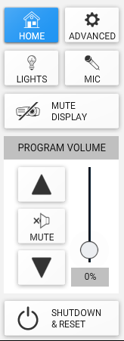
Home

Return to the main auto select page

Advanced

A/V routing

Audio mixer

Lecture capture (if installed)

Display controls

Admin Panel

Lighting (if the room has lighting control interface available)

Microphone (if the room has an active mic)

If the room does not have an active microphone, then the mic volume will be under the advanced menu - audio mixer subpage page. To allow for a temporary install of a microphone

Mute Display

When muted the icon should flash selected state

Program volume

When muted the icon should flash selected state

Adjusting volume up will unmute the system

System Shutdown / Reset

Shut down will
            - Power off / unmute projector
            - Raise projector screen
            - Return lights to all on
            - Reset system to auto mode
            - Mute room audio (with mute button selected)

System reset will
            - Unmute projector
            - Return lights to all on
            - Reset system to auto mode
            - Unmute room audio

AirMedia

Standard teaching & learning spaces will be outfitted with wireless projection via AirMedia. This allows presentations from any device, but does require a dedicated Ethernet port for the AirMedia device as well as a strong wireless network signal in the space.

Variables

On a room-by-room basis, in collaboration with Media Services team members, the number and location of display devices (flat panel monitor vs. projector), the addition of lecture capture/audio reinforcement (speakers and/or microphones), live annotation capabilities (Planar touch screen monitors for installed instructor station computers) and web conferencing (cameras, microphones) will be evaluated for inclusion.

    - Examples of GUI Design
      - Standard Classroom GUI
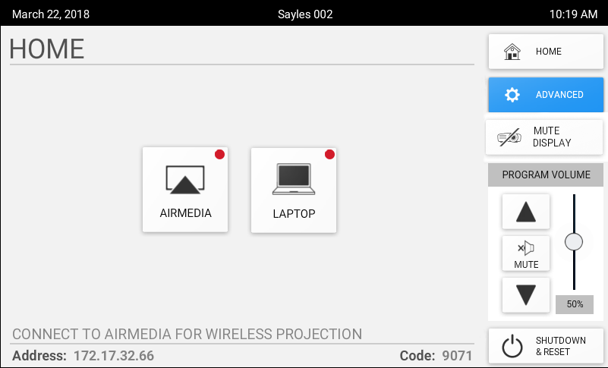
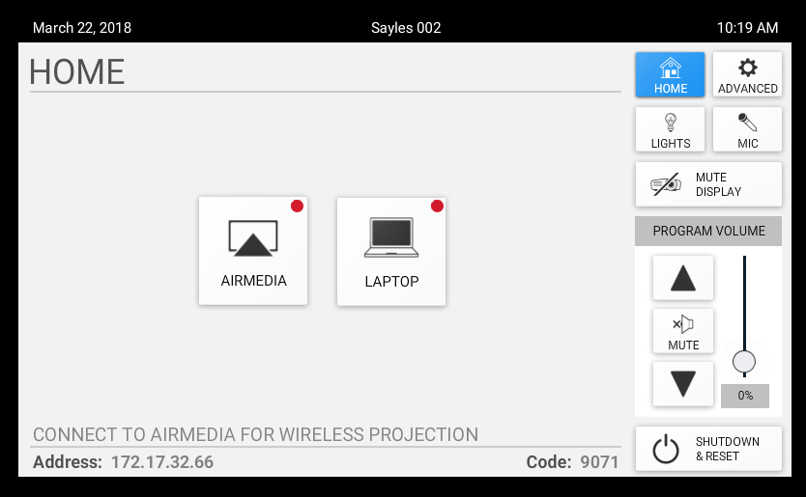
      - Standard Classroom GUI with limited room controls
END OF SECTION

